

**Java Institute for Advanced Technology**

UNIT NAME: SOFTWARE APPLICATION DEVELOPMENT

UNIT ID: H7E1 04

ASSIGNMENT ID: INDIVIDUAL VIVA

NAME: SE M HUSSAIN

SCN NO: 167378196

NIC: 882574687v (0756956193)

BRANCH: Colombo



Introduction

# Purpose

This system is designed for a Student Registration System. This system offers the Classes, Masjids an easy way to keep all kinds of services as well.

# Requirements

To use this system efficiently there are some pre- requirements that the library must have.

* Public Computers
* User/ Admin
* MYSQL Server
* Local Area Network
* WAN (Internet) for Password Changing only
* The LAN must be connected to the MYSQL server and all other computers

# Benefits

This System offers two main use cases. Those are Admin and User. They have very different access levels according to their role they have. Users are easily manageable and processes of the shop can be done more efficiently.

Use Case

There are two types of users in this system. They have different use cases.

# Administrator (Admin)

Administrator

User Registration

Admin can create, disable and edit user accounts.

Student Registration

Admin can create, disable and edit Supplier.

Lecture Registration

Admin can save, update, delete Items of the shop. The items are Ink and Papers

Service Registration

Admin can save, edit, delete Supplier.

Update Active/DE Active

Admin can issue Good Receive Note.

Issue Receipts

Admin can issue Good Receive Note.

Filter Income

Show Income within a selected time Period

Filter Expenses

Show Expense within a selected time Period.

Manage own account

Admin can change the password.

# User

User

Manage own account

Admin can change the password.

Issue an Invoice

User can issue invoice

Manage Class Schedules

User can manage Class Schedules.

ER Diagram

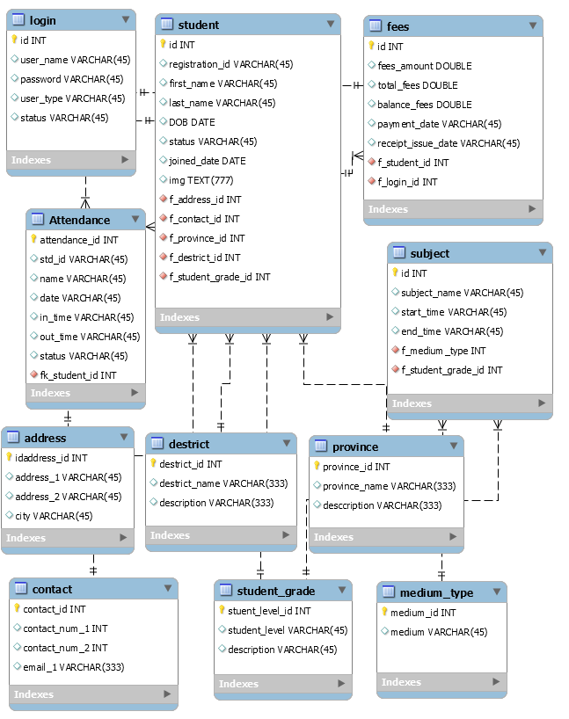

Graphical User Interfaces

# Login



# HOME

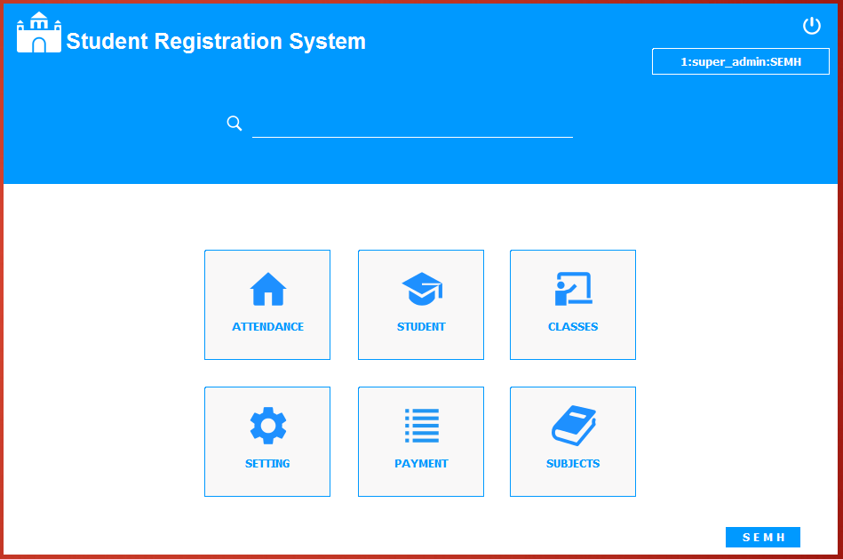

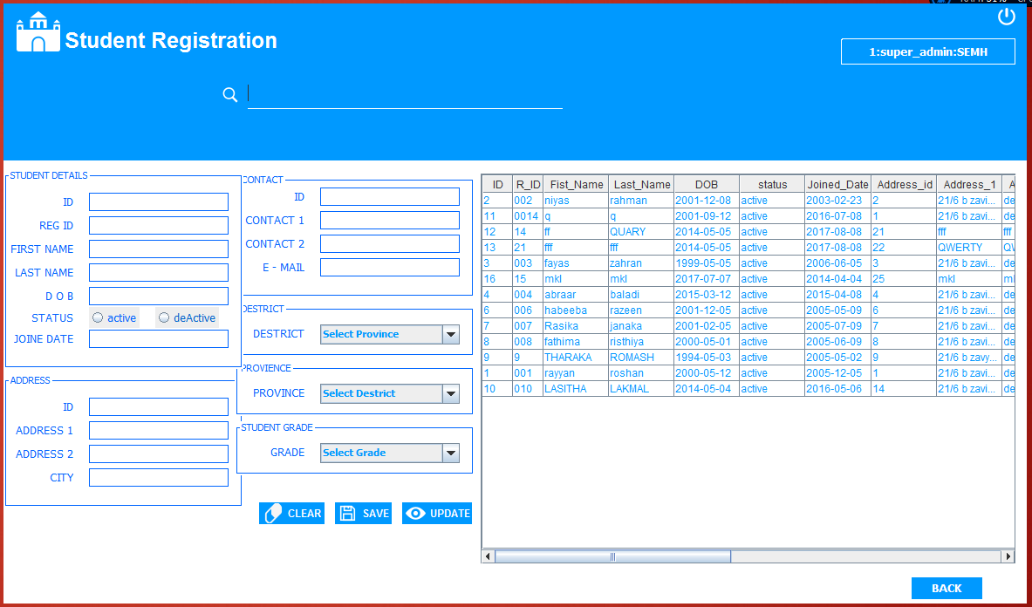

# 

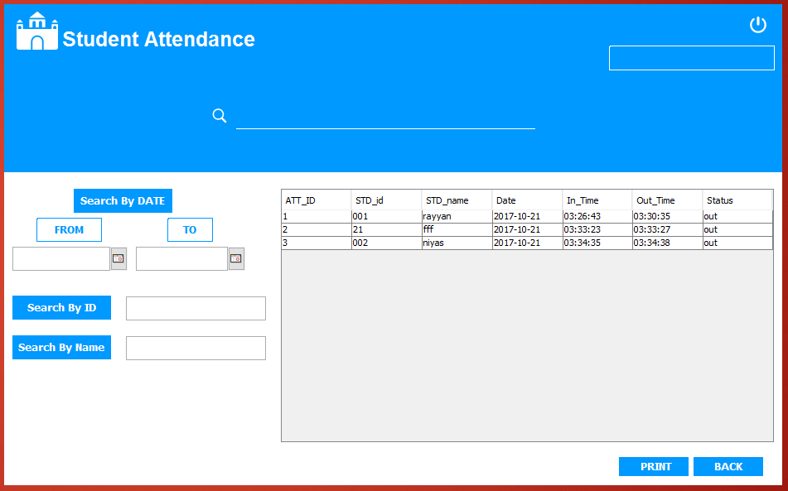

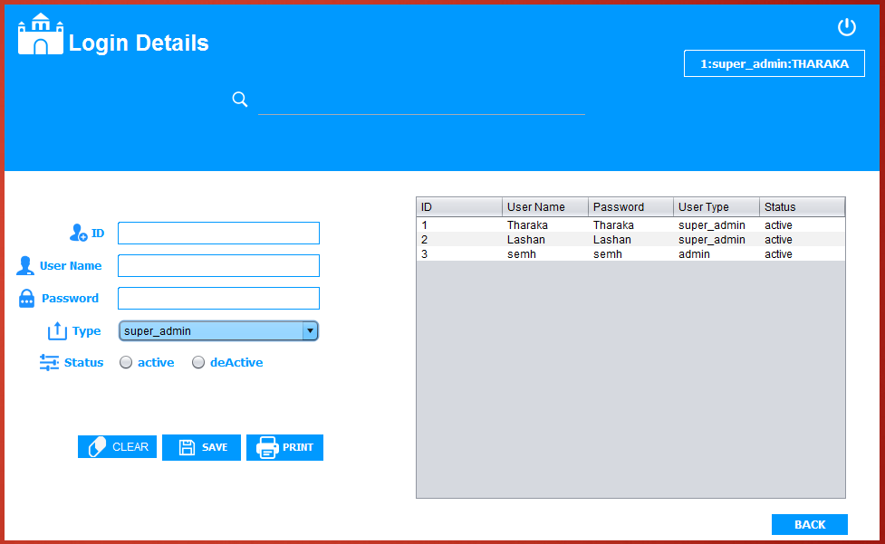

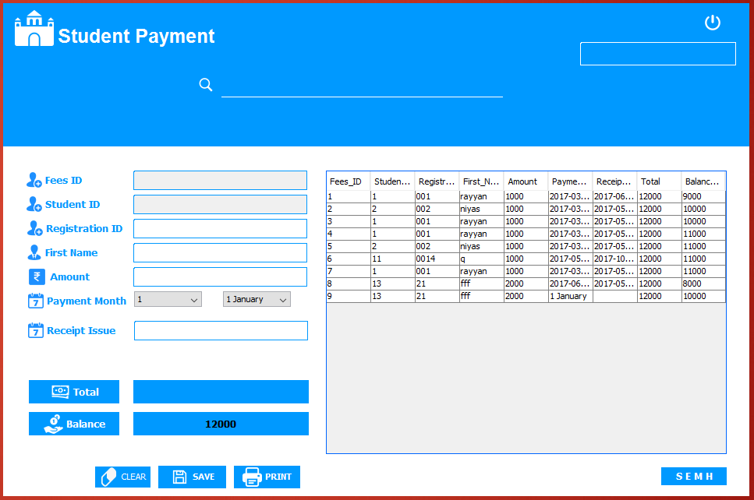

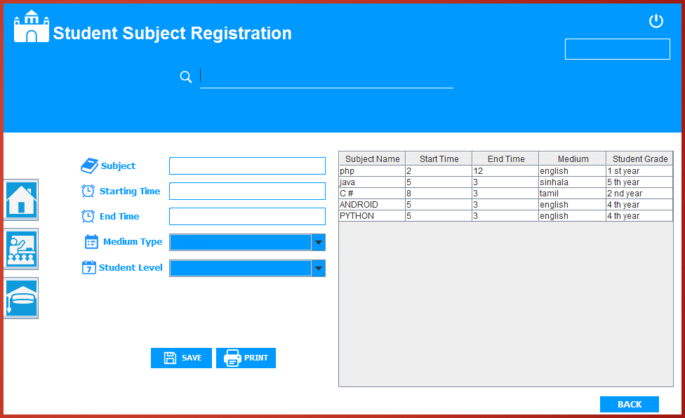

About Us



Splash Screen



Reports

# Receipts

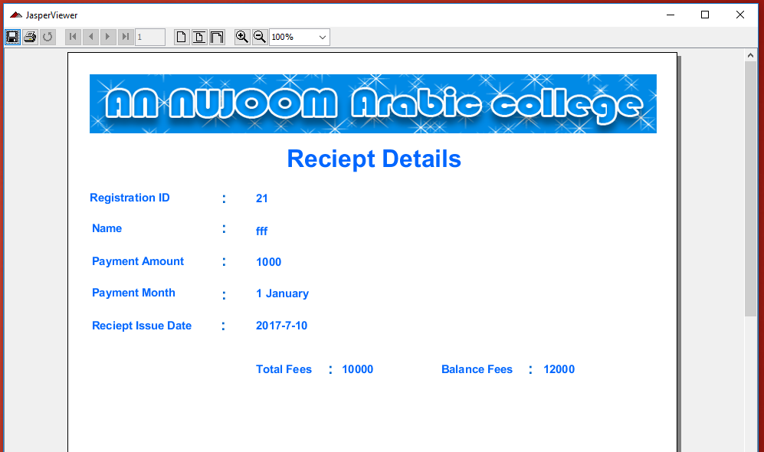

# Time Table

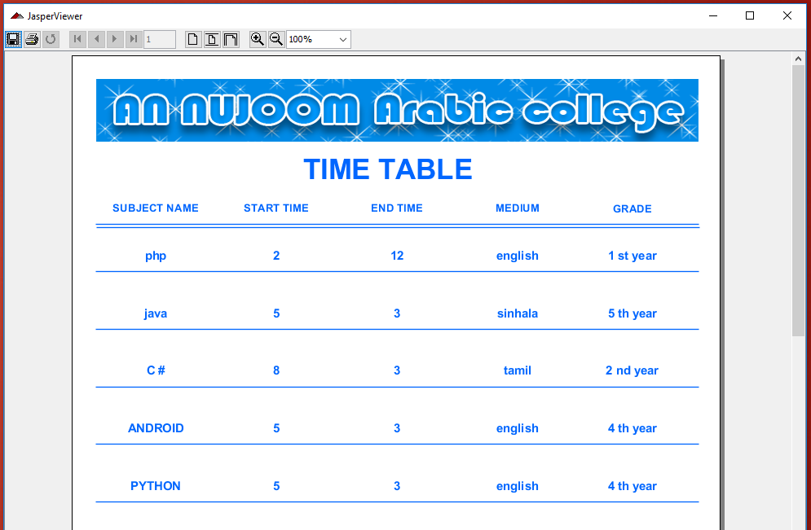

# Student Details

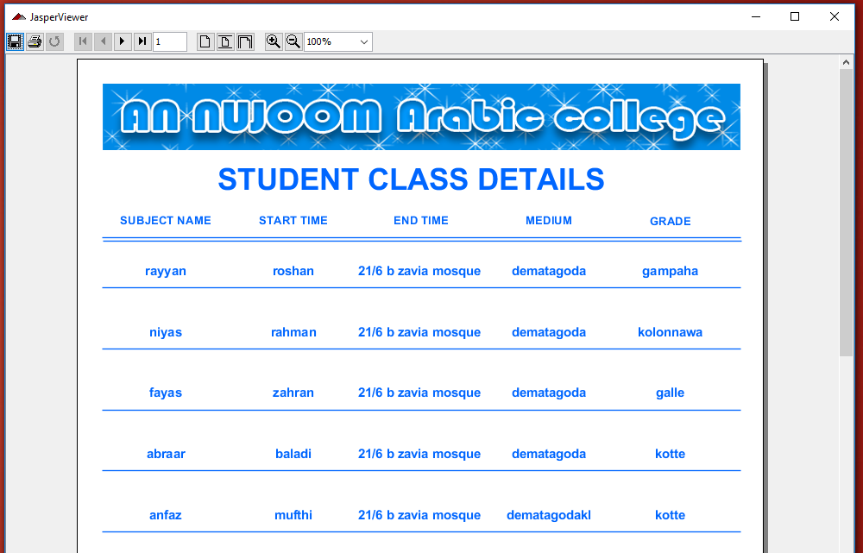

Source Code

**For Main Admin menu**

**package GUI;**

**import java.awt.event.ActionEvent;**

**import java.awt.event.ActionListener;**

**import java.sql.ResultSet;**

**import java.text.SimpleDateFormat;**

**import java.util.Date;**

**import java.util.Vector;**

**import javax.swing.JFrame;**

**import javax.swing.Timer;**

**import javax.swing.table.DefaultTableModel;**

**public class Main_Menu_admin extends javax.swing.JFrame {**

**public Main_Menu_admin() {**

**initComponents();**

**setExtendedState(JFrame.MAXIMIZED_BOTH);**

**//Show the user registration**

**jPanel4.removeAll();**

**jPanel4.add(new User());**

**jPanel4.repaint();**

**jPanel4.revalidate();**

**setTime();**

**}**

**public int id;**

**public Main_Menu_admin(int id) {**

**this();**

**this.id =id;**

**}**

**@SuppressWarnings("unchecked")**

**// <editor-fold defaultstate="collapsed" desc="Generated Code">**

**private void initComponents() {**

**jDialog1 = new javax.swing.JDialog();**

**jScrollPane1 = new javax.swing.JScrollPane();**

**jTable1 = new javax.swing.JTable();**

**jPanel2 = new javax.swing.JPanel();**

**jPanel1 = new javax.swing.JPanel();**

**jLabel16 = new javax.swing.JLabel();**

**jLabel1 = new javax.swing.JLabel();**

**jLabel2 = new javax.swing.JLabel();**

**jLabel5 = new javax.swing.JLabel();**

**jLabel13 = new javax.swing.JLabel();**

**jLabel7 = new javax.swing.JLabel();**

**jLabel8 = new javax.swing.JLabel();**

**jLabel9 = new javax.swing.JLabel();**

**jLabel15 = new javax.swing.JLabel();**

**jLabel6 = new javax.swing.JLabel();**

**jPanel3 = new javax.swing.JPanel();**

**jPanel4 = new javax.swing.JPanel();**

**jLabel3 = new javax.swing.JLabel();**

**jLabel4 = new javax.swing.JLabel();**

**jLabel10 = new javax.swing.JLabel();**

**jLabel11 = new javax.swing.JLabel();**

**jLabel12 = new javax.swing.JLabel();**

**jLabel14 = new javax.swing.JLabel();**

**jLabel18 = new javax.swing.JLabel();**

**jLabel17 = new javax.swing.JLabel();**

**jLabel19 = new javax.swing.JLabel();**

**jLabel20 = new javax.swing.JLabel();**

**jDialog1.setTitle("Low Stock Items");**

**jDialog1.setModalityType(java.awt.Dialog.ModalityType.APPLICATION_MODAL);**

**jTable1.setModel(new javax.swing.table.DefaultTableModel(**

**new Object [][] {**

**},**

**new String [] {**

**"Name", "Brand", "Type", "Quantity"**

**}**

**) {**

**Class[] types = new Class [] {**

**java.lang.String.class, java.lang.String.class, java.lang.String.class, java.lang.String.class**

**};**

**boolean[] canEdit = new boolean [] {**

**false, false, false, false**

**};**

**public Class getColumnClass(int columnIndex) {**

**return types [columnIndex];**

**}**

**public boolean isCellEditable(int rowIndex, int columnIndex) {**

**return canEdit [columnIndex];**

**}**

**});**

**jScrollPane1.setViewportView(jTable1);**

**javax.swing.GroupLayout jDialog1Layout = new javax.swing.GroupLayout(jDialog1.getContentPane());**

**jDialog1.getContentPane().setLayout(jDialog1Layout);**

**jDialog1Layout.setHorizontalGroup(**

**jDialog1Layout.createParallelGroup(javax.swing.GroupLayout.Alignment.LEADING)**

**.addGroup(jDialog1Layout.createSequentialGroup()**

**.addContainerGap()**

**.addComponent(jScrollPane1, javax.swing.GroupLayout.DEFAULT_SIZE, 404, Short.MAX_VALUE)**

**.addContainerGap())**

**);**

**jDialog1Layout.setVerticalGroup(**

**jDialog1Layout.createParallelGroup(javax.swing.GroupLayout.Alignment.LEADING)**

**.addGroup(jDialog1Layout.createSequentialGroup()**

**.addContainerGap()**

**.addComponent(jScrollPane1, javax.swing.GroupLayout.PREFERRED_SIZE, 259, javax.swing.GroupLayout.PREFERRED_SIZE)**

**.addContainerGap(javax.swing.GroupLayout.DEFAULT_SIZE, Short.MAX_VALUE))**

**);**

**setDefaultCloseOperation(javax.swing.WindowConstants.EXIT_ON_CLOSE);**

**setUndecorated(true);**

**jPanel2.setLayout(new org.netbeans.lib.awtextra.AbsoluteLayout());**

**jPanel1.setBackground(new java.awt.Color(30, 136, 229));**

**jPanel1.setLayout(new org.netbeans.lib.awtextra.AbsoluteLayout());**

**jLabel16.setFont(new java.awt.Font("Tahoma", 1, 24)); // NOI18N**

**jLabel16.setForeground(new java.awt.Color(204, 255, 255));**

**jLabel16.setText("Logout");**

**jLabel16.addMouseListener(new java.awt.event.MouseAdapter() {**

**public void mouseClicked(java.awt.event.MouseEvent evt) {**

**jLabel16MouseClicked(evt);**

**}**

**});**

**jPanel1.add(jLabel16, new org.netbeans.lib.awtextra.AbsoluteConstraints(130, 670, 90, 40));**

**jLabel1.setIcon(new javax.swing.ImageIcon(getClass().getResource("/IMG/iCom.jpg"))); // NOI18N**

**jPanel1.add(jLabel1, new org.netbeans.lib.awtextra.AbsoluteConstraints(40, 0, 290, 180));**

**jLabel2.setBackground(new java.awt.Color(0, 0, 102));**

**jLabel2.setFont(new java.awt.Font("Tempus Sans ITC", 1, 24)); // NOI18N**

**jLabel2.setForeground(new java.awt.Color(255, 255, 255));**

**jLabel2.setHorizontalAlignment(javax.swing.SwingConstants.CENTER);**

**jLabel2.setText("User");**

**jLabel2.setBorder(new javax.swing.border.LineBorder(new java.awt.Color(0, 0, 102), 3, true));**

**jLabel2.addMouseListener(new java.awt.event.MouseAdapter() {**

**public void mouseClicked(java.awt.event.MouseEvent evt) {**

**jLabel2MouseClicked(evt);**

**}**

**});**

**jPanel1.add(jLabel2, new org.netbeans.lib.awtextra.AbsoluteConstraints(70, 210, 220, 50));**

**jLabel5.setBackground(new java.awt.Color(0, 0, 102));**

**jLabel5.setFont(new java.awt.Font("Tempus Sans ITC", 1, 24)); // NOI18N**

**jLabel5.setForeground(new java.awt.Color(255, 255, 255));**

**jLabel5.setHorizontalAlignment(javax.swing.SwingConstants.CENTER);**

**jLabel5.setText("Service");**

**jLabel5.setBorder(new javax.swing.border.LineBorder(new java.awt.Color(0, 0, 102), 3, true));**

**jLabel5.addMouseListener(new java.awt.event.MouseAdapter() {**

**public void mouseClicked(java.awt.event.MouseEvent evt) {**

**jLabel5MouseClicked(evt);**

**}**

**});**

**jPanel1.add(jLabel5, new org.netbeans.lib.awtextra.AbsoluteConstraints(70, 390, 220, 50));**

**jLabel13.setBackground(new java.awt.Color(0, 0, 102));**

**jLabel13.setFont(new java.awt.Font("Tempus Sans ITC", 1, 24)); // NOI18N**

**jLabel13.setForeground(new java.awt.Color(255, 255, 255));**

**jLabel13.setHorizontalAlignment(javax.swing.SwingConstants.CENTER);**

**jLabel13.setText("Supplier");**

**jLabel13.setBorder(new javax.swing.border.LineBorder(new java.awt.Color(0, 0, 102), 3, true));**

**jLabel13.addMouseListener(new java.awt.event.MouseAdapter() {**

**public void mouseClicked(java.awt.event.MouseEvent evt) {**

**jLabel13MouseClicked(evt);**

**}**

**});**

**jPanel1.add(jLabel13, new org.netbeans.lib.awtextra.AbsoluteConstraints(70, 270, 220, 50));**

**jLabel7.setBackground(new java.awt.Color(0, 0, 102));**

**jLabel7.setFont(new java.awt.Font("Segoe Print", 1, 24)); // NOI18N**

**jLabel7.setForeground(new java.awt.Color(204, 153, 255));**

**jLabel7.setHorizontalAlignment(javax.swing.SwingConstants.CENTER);**

**jLabel7.setIcon(new javax.swing.ImageIcon(getClass().getResource("/IMG/lg.colorful-progress-loader[1].gif"))); // NOI18N**

**jLabel7.setIconTextGap(20);**

**jLabel7.addMouseListener(new java.awt.event.MouseAdapter() {**

**public void mouseClicked(java.awt.event.MouseEvent evt) {**

**jLabel7MouseClicked(evt);**

**}**

**});**

**jPanel1.add(jLabel7, new org.netbeans.lib.awtextra.AbsoluteConstraints(50, 650, 250, 80));**

**jLabel8.setBackground(new java.awt.Color(0, 0, 102));**

**jLabel8.setFont(new java.awt.Font("Tempus Sans ITC", 1, 24)); // NOI18N**

**jLabel8.setForeground(new java.awt.Color(255, 255, 255));**

**jLabel8.setHorizontalAlignment(javax.swing.SwingConstants.CENTER);**

**jLabel8.setText("Stock");**

**jLabel8.setBorder(new javax.swing.border.LineBorder(new java.awt.Color(0, 0, 102), 3, true));**

**jLabel8.addMouseListener(new java.awt.event.MouseAdapter() {**

**public void mouseClicked(java.awt.event.MouseEvent evt) {**

**jLabel8MouseClicked(evt);**

**}**

**});**

**jPanel1.add(jLabel8, new org.netbeans.lib.awtextra.AbsoluteConstraints(70, 450, 220, 50));**

**jLabel9.setBackground(new java.awt.Color(0, 0, 102));**

**jLabel9.setFont(new java.awt.Font("Tempus Sans ITC", 1, 24)); // NOI18N**

**jLabel9.setForeground(new java.awt.Color(255, 255, 255));**

**jLabel9.setHorizontalAlignment(javax.swing.SwingConstants.CENTER);**

**jLabel9.setText("Income");**

**jLabel9.setBorder(new javax.swing.border.LineBorder(new java.awt.Color(0, 0, 102), 3, true));**

**jLabel9.addMouseListener(new java.awt.event.MouseAdapter() {**

**public void mouseClicked(java.awt.event.MouseEvent evt) {**

**jLabel9MouseClicked(evt);**

**}**

**});**

**jPanel1.add(jLabel9, new org.netbeans.lib.awtextra.AbsoluteConstraints(70, 510, 220, 50));**

**jLabel15.setBackground(new java.awt.Color(0, 0, 102));**

**jLabel15.setFont(new java.awt.Font("Tempus Sans ITC", 1, 24)); // NOI18N**

**jLabel15.setForeground(new java.awt.Color(255, 255, 255));**

**jLabel15.setHorizontalAlignment(javax.swing.SwingConstants.CENTER);**

**jLabel15.setText("Expences");**

**jLabel15.setBorder(new javax.swing.border.LineBorder(new java.awt.Color(0, 0, 102), 3, true));**

**jLabel15.addMouseListener(new java.awt.event.MouseAdapter() {**

**public void mouseClicked(java.awt.event.MouseEvent evt) {**

**jLabel15MouseClicked(evt);**

**}**

**});**

**jPanel1.add(jLabel15, new org.netbeans.lib.awtextra.AbsoluteConstraints(70, 570, 220, 50));**

**jLabel6.setBackground(new java.awt.Color(0, 0, 102));**

**jLabel6.setFont(new java.awt.Font("Tempus Sans ITC", 1, 24)); // NOI18N**

**jLabel6.setForeground(new java.awt.Color(255, 255, 255));**

**jLabel6.setHorizontalAlignment(javax.swing.SwingConstants.CENTER);**

**jLabel6.setText("Item");**

**jLabel6.setBorder(new javax.swing.border.LineBorder(new java.awt.Color(0, 0, 102), 3, true));**

**jLabel6.addMouseListener(new java.awt.event.MouseAdapter() {**

**public void mouseClicked(java.awt.event.MouseEvent evt) {**

**jLabel6MouseClicked(evt);**

**}**

**});**

**jPanel1.add(jLabel6, new org.netbeans.lib.awtextra.AbsoluteConstraints(70, 330, 220, 50));**

**jPanel2.add(jPanel1, new org.netbeans.lib.awtextra.AbsoluteConstraints(0, 0, 370, 770));**

**jPanel3.setBackground(new java.awt.Color(144, 202, 249));**

**jPanel3.setForeground(new java.awt.Color(0, 102, 255));**

**jPanel3.setLayout(new org.netbeans.lib.awtextra.AbsoluteLayout());**

**jPanel4.setBackground(jPanel3.getBackground());**

**jPanel4.setPreferredSize(new java.awt.Dimension(860, 580));**

**jPanel4.setRequestFocusEnabled(false);**

**jPanel4.setLayout(new javax.swing.BoxLayout(jPanel4, javax.swing.BoxLayout.LINE_AXIS));**

**jPanel3.add(jPanel4, new org.netbeans.lib.awtextra.AbsoluteConstraints(70, 110, 860, 580));**

**jLabel3.setFont(new java.awt.Font("Lucida Handwriting", 1, 40)); // NOI18N**

**jLabel3.setForeground(new java.awt.Color(0, 102, 255));**

**jLabel3.setHorizontalAlignment(javax.swing.SwingConstants.CENTER);**

**jLabel3.setText("Time");**

**jPanel3.add(jLabel3, new org.netbeans.lib.awtextra.AbsoluteConstraints(610, 20, 280, 60));**

**jLabel4.setFont(new java.awt.Font("Tempus Sans ITC", 1, 24)); // NOI18N**

**jLabel4.setForeground(new java.awt.Color(0, 153, 102));**

**jLabel4.setHorizontalAlignment(javax.swing.SwingConstants.CENTER);**

**jLabel4.setText("Date");**

**jPanel3.add(jLabel4, new org.netbeans.lib.awtextra.AbsoluteConstraints(610, 70, 270, 30));**

**jLabel10.setFont(new java.awt.Font("Maiandra GD", 1, 60)); // NOI18N**

**jLabel10.setText("iPrint...");**

**jPanel3.add(jLabel10, new org.netbeans.lib.awtextra.AbsoluteConstraints(30, 20, 250, 70));**

**jLabel11.setHorizontalAlignment(javax.swing.SwingConstants.CENTER);**

**jLabel11.setIcon(new javax.swing.ImageIcon(getClass().getResource("/IMG/Close Window_30px_1.png"))); // NOI18N**

**jLabel11.addMouseListener(new java.awt.event.MouseAdapter() {**

**public void mouseClicked(java.awt.event.MouseEvent evt) {**

**jLabel11MouseClicked(evt);**

**}**

**});**

**jPanel3.add(jLabel11, new org.netbeans.lib.awtextra.AbsoluteConstraints(960, 10, -1, 30));**

**jLabel12.setHorizontalAlignment(javax.swing.SwingConstants.CENTER);**

**jLabel12.setIcon(new javax.swing.ImageIcon(getClass().getResource("/IMG/Minimize Window_30px.png"))); // NOI18N**

**jLabel12.addMouseListener(new java.awt.event.MouseAdapter() {**

**public void mouseClicked(java.awt.event.MouseEvent evt) {**

**jLabel12MouseClicked(evt);**

**}**

**});**

**jPanel3.add(jLabel12, new org.netbeans.lib.awtextra.AbsoluteConstraints(920, 10, 30, 30));**

**jLabel14.setFont(new java.awt.Font("Tempus Sans ITC", 1, 18)); // NOI18N**

**jLabel14.setForeground(new java.awt.Color(255, 255, 255));**

**jLabel14.setHorizontalAlignment(javax.swing.SwingConstants.CENTER);**

**jLabel14.setText("am");**

**jPanel3.add(jLabel14, new org.netbeans.lib.awtextra.AbsoluteConstraints(840, 40, 60, -1));**

**jLabel18.setBackground(new java.awt.Color(0, 0, 102));**

**jLabel18.setFont(new java.awt.Font("Trebuchet MS", 1, 24)); // NOI18N**

**jLabel18.setForeground(new java.awt.Color(51, 51, 51));**

**jLabel18.setHorizontalAlignment(javax.swing.SwingConstants.CENTER);**

**jLabel18.setText("Invoice");**

**jLabel18.setBorder(new javax.swing.border.LineBorder(new java.awt.Color(0, 102, 102), 3, true));**

**jLabel18.addMouseListener(new java.awt.event.MouseAdapter() {**

**public void mouseClicked(java.awt.event.MouseEvent evt) {**

**jLabel18MouseClicked(evt);**

**}**

**});**

**jPanel3.add(jLabel18, new org.netbeans.lib.awtextra.AbsoluteConstraints(580, 710, 150, -1));**

**jLabel17.setBackground(new java.awt.Color(0, 0, 102));**

**jLabel17.setFont(new java.awt.Font("Trebuchet MS", 1, 24)); // NOI18N**

**jLabel17.setForeground(new java.awt.Color(51, 51, 51));**

**jLabel17.setHorizontalAlignment(javax.swing.SwingConstants.CENTER);**

**jLabel17.setText("GRN");**

**jLabel17.setBorder(new javax.swing.border.LineBorder(new java.awt.Color(0, 102, 102), 3, true));**

**jLabel17.addMouseListener(new java.awt.event.MouseAdapter() {**

**public void mouseClicked(java.awt.event.MouseEvent evt) {**

**jLabel17MouseClicked(evt);**

**}**

**});**

**jPanel3.add(jLabel17, new org.netbeans.lib.awtextra.AbsoluteConstraints(770, 710, 160, -1));**

**jLabel19.setFont(new java.awt.Font("Tahoma", 1, 18)); // NOI18N**

**jLabel19.setText("User Access");**

**jPanel3.add(jLabel19, new org.netbeans.lib.awtextra.AbsoluteConstraints(410, 720, -1, -1));**

**jLabel20.setBackground(new java.awt.Color(0, 0, 102));**

**jLabel20.setFont(new java.awt.Font("Trebuchet MS", 0, 18)); // NOI18N**

**jLabel20.setForeground(new java.awt.Color(0, 51, 153));**

**jLabel20.setHorizontalAlignment(javax.swing.SwingConstants.CENTER);**

**jLabel20.setText("Change Password");**

**jLabel20.setBorder(new javax.swing.border.LineBorder(new java.awt.Color(102, 0, 153), 2, true));**

**jLabel20.addMouseListener(new java.awt.event.MouseAdapter() {**

**public void mouseClicked(java.awt.event.MouseEvent evt) {**

**jLabel20MouseClicked(evt);**

**}**

**});**

**jPanel3.add(jLabel20, new org.netbeans.lib.awtextra.AbsoluteConstraints(80, 710, 190, 40));**

**jPanel2.add(jPanel3, new org.netbeans.lib.awtextra.AbsoluteConstraints(370, 0, 1000, 770));**

**javax.swing.GroupLayout layout = new javax.swing.GroupLayout(getContentPane());**

**getContentPane().setLayout(layout);**

**layout.setHorizontalGroup(**

**layout.createParallelGroup(javax.swing.GroupLayout.Alignment.LEADING)**

**.addGroup(layout.createSequentialGroup()**

**.addComponent(jPanel2, javax.swing.GroupLayout.PREFERRED_SIZE, javax.swing.GroupLayout.DEFAULT_SIZE, javax.swing.GroupLayout.PREFERRED_SIZE)**

**.addGap(0, 0, Short.MAX_VALUE))**

**);**

**layout.setVerticalGroup(**

**layout.createParallelGroup(javax.swing.GroupLayout.Alignment.LEADING)**

**.addGroup(layout.createSequentialGroup()**

**.addComponent(jPanel2, javax.swing.GroupLayout.PREFERRED_SIZE, javax.swing.GroupLayout.DEFAULT_SIZE, javax.swing.GroupLayout.PREFERRED_SIZE)**

**.addGap(0, 0, Short.MAX_VALUE))**

**);**

**pack();**

**setLocationRelativeTo(null);**

**}// </editor-fold>**

**private void setTime() {**

**updateTime();**

**Timer timer = new Timer(500, new ActionListener() {**

**@Override**

**public void actionPerformed(ActionEvent e) {**

**updateTime();**

**}**

**});**

**timer.start();**

**}**

**private void updateTime() {**

**Date date = new Date();**

**SimpleDateFormat sd = new SimpleDateFormat("hh:mm:ss");**

**SimpleDateFormat sd0 = new SimpleDateFormat("aa");//am**

**SimpleDateFormat sd1 = new SimpleDateFormat("dd MMM yyyy");**

**jLabel3.setText(sd.format(date));**

**jLabel4.setText(sd1.format(date));**

**jLabel14.setText(sd0.format(date));**

**}**

**private void jLabel2MouseClicked(java.awt.event.MouseEvent evt) {**

**jPanel4.removeAll();**

**jPanel4.add(new User());**

**jPanel4.repaint();**

**jPanel4.revalidate();**

**}**

**private void jLabel5MouseClicked(java.awt.event.MouseEvent evt) {**

**jPanel4.removeAll();**

**jPanel4.add(new Service_Reg());**

**jPanel4.repaint();**

**jPanel4.revalidate();**

**}**

**private void jLabel13MouseClicked(java.awt.event.MouseEvent evt) {**

**jPanel4.removeAll();**

**jPanel4.add(new Sup_reg(this));**

**jPanel4.repaint();**

**jPanel4.revalidate();**

**}**

**private void jLabel7MouseClicked(java.awt.event.MouseEvent evt) {**

**Login log = new Login();**

**log.setVisible(true);**

**dispose();**

**}**

**private void jLabel8MouseClicked(java.awt.event.MouseEvent evt) {**

**jPanel4.removeAll();**

**jPanel4.add(new Stock());**

**jPanel4.repaint();**

**jPanel4.revalidate();**

**// Stock Notification**

**String q = "select Page,qty from Page Where status = '1' and qty < '100'";**

**String q1 = "select color,qty,brand from ink Where status = '1' and qty < '10'";**

**DefaultTableModel dt = (DefaultTableModel) jTable1.getModel();**

**try {**

**ResultSet rs1 = DataBase.DBase.getData(q);**

**dt.setRowCount(0);**

**while (rs1.next()) {**

**Vector v = new Vector();**

**v.add(rs1.getString("Page"));**

**v.add("Promate");**

**v.add("Paper");**

**v.add(rs1.getString("qty"));**

**dt.addRow(v);**

**}**

**ResultSet rs2 = DataBase.DBase.getData(q1);**

**while (rs2.next()) {**

**Vector v = new Vector();**

**v.add(rs2.getString("color"));**

**v.add(rs2.getString("brand"));**

**v.add("ink");**

**v.add(rs2.getString("qty"));**

**dt.addRow(v);**

**}**

**} catch (Exception e) {**

**e.printStackTrace();**

**}**

**if (jTable1.getRowCount() > 0) {**

**jDialog1.setLocationRelativeTo(null);**

**jDialog1.setSize(jDialog1.getPreferredSize());**

**jDialog1.setVisible(true);**

**}**

**}**

**private void jLabel9MouseClicked(java.awt.event.MouseEvent evt) {**

**jPanel4.removeAll();**

**jPanel4.add(new Income(this));**

**jPanel4.repaint();**

**jPanel4.revalidate();**

**}**

**private void jLabel12MouseClicked(java.awt.event.MouseEvent evt) {**

**setState(ICONIFIED);**

**}**

**private void jLabel11MouseClicked(java.awt.event.MouseEvent evt) {**

**System.exit(0);**

**}**

**private void jLabel15MouseClicked(java.awt.event.MouseEvent evt) {**

**jPanel4.removeAll();**

**jPanel4.add(new Expenses(this));**

**jPanel4.repaint();**

**jPanel4.revalidate();**

**}**

**private void jLabel6MouseClicked(java.awt.event.MouseEvent evt) {**

**jPanel4.removeAll();**

**jPanel4.add(new Items());**

**jPanel4.repaint();**

**jPanel4.revalidate();**

**}**

**private void jLabel16MouseClicked(java.awt.event.MouseEvent evt) {**

**Login log = new Login();**

**log.setVisible(true);**

**dispose();**

**}**

**private void jLabel17MouseClicked(java.awt.event.MouseEvent evt) {**

**jPanel4.removeAll();**

**jPanel4.add(new GRN(this));**

**jPanel4.repaint();**

**jPanel4.revalidate();**

**}**

**private void jLabel18MouseClicked(java.awt.event.MouseEvent evt) {**

**jPanel4.removeAll();**

**jPanel4.add(new Invoice(this));**

**jPanel4.repaint();**

**jPanel4.revalidate();**

**}**

**private void jLabel20MouseClicked(java.awt.event.MouseEvent evt) {**

**jPanel4.removeAll();**

**jPanel4.add(new change_pw(this,id));**

**jPanel4.repaint();**

**jPanel4.revalidate();**

**// TODO add your handling code here:**

**}**

**/\*\***

**\* @param args the command line arguments**

**\*/**

**public static void main(String args[]) {**

**/* Set the Nimbus look and feel */**

**//<editor-fold defaultstate="collapsed" desc=" Look and feel setting code (optional) ">**

**/* If Nimbus (introduced in Java SE 6) is not available, stay with the default look and feel.**

**\* For details see http://download.oracle.com/javase/tutorial/uiswing/lookandfeel/plaf.html**

**\*/**

**try {**

**for (javax.swing.UIManager.LookAndFeelInfo info : javax.swing.UIManager.getInstalledLookAndFeels()) {**

**if ("Nimbus".equals(info.getName())) {**

**javax.swing.UIManager.setLookAndFeel(info.getClassName());**

**break;**

**}**

**}**

**} catch (ClassNotFoundException ex) {**

**java.util.logging.Logger.getLogger(Main_Menu_admin.class.getName()).log(java.util.logging.Level.SEVERE, null, ex);**

**} catch (InstantiationException ex) {**

**java.util.logging.Logger.getLogger(Main_Menu_admin.class.getName()).log(java.util.logging.Level.SEVERE, null, ex);**

**} catch (IllegalAccessException ex) {**

**java.util.logging.Logger.getLogger(Main_Menu_admin.class.getName()).log(java.util.logging.Level.SEVERE, null, ex);**

**} catch (javax.swing.UnsupportedLookAndFeelException ex) {**

**java.util.logging.Logger.getLogger(Main_Menu_admin.class.getName()).log(java.util.logging.Level.SEVERE, null, ex);**

**}**

**//</editor-fold>**

**/* Create and display the form */**

**java.awt.EventQueue.invokeLater(new Runnable() {**

**public void run() {**

**new Main_Menu_admin().setVisible(true);**

**}**

**});**

**}**

**// Variables declaration - do not modify**

**private javax.swing.JDialog jDialog1;**

**private javax.swing.JLabel jLabel1;**

**private javax.swing.JLabel jLabel10;**

**private javax.swing.JLabel jLabel11;**

**private javax.swing.JLabel jLabel12;**

**private javax.swing.JLabel jLabel13;**

**private javax.swing.JLabel jLabel14;**

**private javax.swing.JLabel jLabel15;**

**private javax.swing.JLabel jLabel16;**

**private javax.swing.JLabel jLabel17;**

**private javax.swing.JLabel jLabel18;**

**private javax.swing.JLabel jLabel19;**

**private javax.swing.JLabel jLabel2;**

**private javax.swing.JLabel jLabel20;**

**private javax.swing.JLabel jLabel3;**

**private javax.swing.JLabel jLabel4;**

**private javax.swing.JLabel jLabel5;**

**private javax.swing.JLabel jLabel6;**

**private javax.swing.JLabel jLabel7;**

**private javax.swing.JLabel jLabel8;**

**private javax.swing.JLabel jLabel9;**

**private javax.swing.JPanel jPanel1;**

**private javax.swing.JPanel jPanel2;**

**private javax.swing.JPanel jPanel3;**

**private javax.swing.JPanel jPanel4;**

**private javax.swing.JScrollPane jScrollPane1;**

**private javax.swing.JTable jTable1;**

**// End of variables declaration**

**}**

**For Main user menu**

**package GUI;**

**import java.awt.event.ActionEvent;**

**import java.awt.event.ActionListener;**

**import java.text.SimpleDateFormat;**

**import java.util.Date;**

**import javax.swing.JFrame;**

**import javax.swing.Timer;**

**public class Main_Menu_user extends javax.swing.JFrame {**

**public Main_Menu_user() {**

**initComponents();**

**setExtendedState(JFrame.MAXIMIZED_BOTH);**

**jPanel4.removeAll();**

**jPanel4.add(new Invoice(this));**

**jPanel4.repaint();**

**jPanel4.revalidate();**

**setTime();**

**}**

**public int id ;**

**public Main_Menu_user(int id) {**

**this();**

**this.id = id;**

**}**

**@SuppressWarnings("unchecked")**

**// <editor-fold defaultstate="collapsed" desc="Generated Code">**

**private void initComponents() {**

**jPanel2 = new javax.swing.JPanel();**

**jPanel1 = new javax.swing.JPanel();**

**jLabel16 = new javax.swing.JLabel();**

**jLabel1 = new javax.swing.JLabel();**

**jLabel8 = new javax.swing.JLabel();**

**jLabel13 = new javax.swing.JLabel();**

**jLabel7 = new javax.swing.JLabel();**

**jLabel21 = new javax.swing.JLabel();**

**jPanel3 = new javax.swing.JPanel();**

**jPanel4 = new javax.swing.JPanel();**

**jLabel10 = new javax.swing.JLabel();**

**jLabel11 = new javax.swing.JLabel();**

**jLabel12 = new javax.swing.JLabel();**

**jLabel4 = new javax.swing.JLabel();**

**jLabel3 = new javax.swing.JLabel();**

**jLabel14 = new javax.swing.JLabel();**

**setDefaultCloseOperation(javax.swing.WindowConstants.EXIT_ON_CLOSE);**

**setUndecorated(true);**

**jPanel2.setLayout(new org.netbeans.lib.awtextra.AbsoluteLayout());**

**jPanel1.setBackground(new java.awt.Color(60, 122, 180));**

**jPanel1.setLayout(new org.netbeans.lib.awtextra.AbsoluteLayout());**

**jLabel16.setFont(new java.awt.Font("Tahoma", 1, 24)); // NOI18N**

**jLabel16.setForeground(new java.awt.Color(204, 255, 255));**

**jLabel16.setText("Logout");**

**jLabel16.addMouseListener(new java.awt.event.MouseAdapter() {**

**public void mouseClicked(java.awt.event.MouseEvent evt) {**

**jLabel16MouseClicked(evt);**

**}**

**});**

**jPanel1.add(jLabel16, new org.netbeans.lib.awtextra.AbsoluteConstraints(160, 610, 100, -1));**

**jLabel1.setIcon(new javax.swing.ImageIcon(getClass().getResource("/IMG/iCom.jpg"))); // NOI18N**

**jPanel1.add(jLabel1, new org.netbeans.lib.awtextra.AbsoluteConstraints(40, 20, 290, 180));**

**jLabel8.setBackground(new java.awt.Color(0, 0, 102));**

**jLabel8.setFont(new java.awt.Font("Tempus Sans ITC", 1, 24)); // NOI18N**

**jLabel8.setForeground(new java.awt.Color(255, 255, 255));**

**jLabel8.setHorizontalAlignment(javax.swing.SwingConstants.CENTER);**

**jLabel8.setText("Invoice");**

**jLabel8.setBorder(new javax.swing.border.LineBorder(new java.awt.Color(0, 0, 102), 3, true));**

**jLabel8.addMouseListener(new java.awt.event.MouseAdapter() {**

**public void mouseClicked(java.awt.event.MouseEvent evt) {**

**jLabel8MouseClicked(evt);**

**}**

**});**

**jPanel1.add(jLabel8, new org.netbeans.lib.awtextra.AbsoluteConstraints(100, 310, 190, 50));**

**jLabel13.setBackground(new java.awt.Color(0, 0, 102));**

**jLabel13.setFont(new java.awt.Font("Tempus Sans ITC", 1, 24)); // NOI18N**

**jLabel13.setForeground(new java.awt.Color(255, 255, 255));**

**jLabel13.setHorizontalAlignment(javax.swing.SwingConstants.CENTER);**

**jLabel13.setText("GRN");**

**jLabel13.setBorder(new javax.swing.border.LineBorder(new java.awt.Color(0, 0, 102), 3, true));**

**jLabel13.addMouseListener(new java.awt.event.MouseAdapter() {**

**public void mouseClicked(java.awt.event.MouseEvent evt) {**

**jLabel13MouseClicked(evt);**

**}**

**});**

**jPanel1.add(jLabel13, new org.netbeans.lib.awtextra.AbsoluteConstraints(100, 440, 190, 50));**

**jLabel7.setBackground(new java.awt.Color(0, 0, 102));**

**jLabel7.setFont(new java.awt.Font("Segoe Print", 1, 24)); // NOI18N**

**jLabel7.setForeground(new java.awt.Color(204, 153, 255));**

**jLabel7.setHorizontalAlignment(javax.swing.SwingConstants.CENTER);**

**jLabel7.setIcon(new javax.swing.ImageIcon(getClass().getResource("/IMG/lg.colorful-progress-loader[1].gif"))); // NOI18N**

**jLabel7.setIconTextGap(20);**

**jLabel7.addMouseListener(new java.awt.event.MouseAdapter() {**

**public void mouseClicked(java.awt.event.MouseEvent evt) {**

**jLabel7MouseClicked(evt);**

**}**

**});**

**jPanel1.add(jLabel7, new org.netbeans.lib.awtextra.AbsoluteConstraints(80, 580, 250, 80));**

**jLabel21.setBackground(new java.awt.Color(0, 0, 102));**

**jLabel21.setFont(new java.awt.Font("Trebuchet MS", 0, 18)); // NOI18N**

**jLabel21.setForeground(new java.awt.Color(0, 255, 255));**

**jLabel21.setHorizontalAlignment(javax.swing.SwingConstants.CENTER);**

**jLabel21.setText("Change Password");**

**jLabel21.setBorder(new javax.swing.border.LineBorder(new java.awt.Color(102, 0, 153), 2, true));**

**jLabel21.addMouseListener(new java.awt.event.MouseAdapter() {**

**public void mouseClicked(java.awt.event.MouseEvent evt) {**

**jLabel21MouseClicked(evt);**

**}**

**});**

**jPanel1.add(jLabel21, new org.netbeans.lib.awtextra.AbsoluteConstraints(110, 700, 190, 40));**

**jPanel2.add(jPanel1, new org.netbeans.lib.awtextra.AbsoluteConstraints(0, 0, 370, 770));**

**jPanel3.setBackground(new java.awt.Color(144, 202, 249));**

**jPanel3.setLayout(new org.netbeans.lib.awtextra.AbsoluteLayout());**

**jPanel4.setBackground(jPanel3.getBackground());**

**jPanel4.setPreferredSize(new java.awt.Dimension(860, 580));**

**jPanel4.setRequestFocusEnabled(false);**

**jPanel4.setLayout(new javax.swing.BoxLayout(jPanel4, javax.swing.BoxLayout.LINE_AXIS));**

**jPanel3.add(jPanel4, new org.netbeans.lib.awtextra.AbsoluteConstraints(70, 130, 860, 580));**

**jLabel10.setFont(new java.awt.Font("Maiandra GD", 1, 60)); // NOI18N**

**jLabel10.setText("iPrint...");**

**jPanel3.add(jLabel10, new org.netbeans.lib.awtextra.AbsoluteConstraints(30, 20, 250, 70));**

**jLabel11.setHorizontalAlignment(javax.swing.SwingConstants.CENTER);**

**jLabel11.setIcon(new javax.swing.ImageIcon(getClass().getResource("/IMG/Close Window_30px_1.png"))); // NOI18N**

**jLabel11.addMouseListener(new java.awt.event.MouseAdapter() {**

**public void mouseClicked(java.awt.event.MouseEvent evt) {**

**jLabel11MouseClicked(evt);**

**}**

**});**

**jPanel3.add(jLabel11, new org.netbeans.lib.awtextra.AbsoluteConstraints(960, 10, -1, 30));**

**jLabel12.setHorizontalAlignment(javax.swing.SwingConstants.CENTER);**

**jLabel12.setIcon(new javax.swing.ImageIcon(getClass().getResource("/IMG/Minimize Window_30px.png"))); // NOI18N**

**jLabel12.addMouseListener(new java.awt.event.MouseAdapter() {**

**public void mouseClicked(java.awt.event.MouseEvent evt) {**

**jLabel12MouseClicked(evt);**

**}**

**});**

**jPanel3.add(jLabel12, new org.netbeans.lib.awtextra.AbsoluteConstraints(920, 10, 30, 30));**

**jLabel4.setFont(new java.awt.Font("Tempus Sans ITC", 1, 24)); // NOI18N**

**jLabel4.setForeground(new java.awt.Color(102, 255, 153));**

**jLabel4.setHorizontalAlignment(javax.swing.SwingConstants.CENTER);**

**jLabel4.setText("Date");**

**jPanel3.add(jLabel4, new org.netbeans.lib.awtextra.AbsoluteConstraints(600, 80, 270, 30));**

**jLabel3.setFont(new java.awt.Font("Lucida Handwriting", 1, 40)); // NOI18N**

**jLabel3.setForeground(new java.awt.Color(0, 255, 255));**

**jLabel3.setHorizontalAlignment(javax.swing.SwingConstants.CENTER);**

**jLabel3.setText("Time");**

**jPanel3.add(jLabel3, new org.netbeans.lib.awtextra.AbsoluteConstraints(600, 30, 280, 60));**

**jLabel14.setFont(new java.awt.Font("Tempus Sans ITC", 1, 18)); // NOI18N**

**jLabel14.setForeground(new java.awt.Color(255, 255, 255));**

**jLabel14.setHorizontalAlignment(javax.swing.SwingConstants.CENTER);**

**jLabel14.setText("am");**

**jPanel3.add(jLabel14, new org.netbeans.lib.awtextra.AbsoluteConstraints(830, 50, 60, -1));**

**jPanel2.add(jPanel3, new org.netbeans.lib.awtextra.AbsoluteConstraints(370, 0, 1000, 770));**

**javax.swing.GroupLayout layout = new javax.swing.GroupLayout(getContentPane());**

**getContentPane().setLayout(layout);**

**layout.setHorizontalGroup(**

**layout.createParallelGroup(javax.swing.GroupLayout.Alignment.LEADING)**

**.addGroup(layout.createSequentialGroup()**

**.addComponent(jPanel2, javax.swing.GroupLayout.PREFERRED_SIZE, javax.swing.GroupLayout.DEFAULT_SIZE, javax.swing.GroupLayout.PREFERRED_SIZE)**

**.addGap(0, 0, Short.MAX_VALUE))**

**);**

**layout.setVerticalGroup(**

**layout.createParallelGroup(javax.swing.GroupLayout.Alignment.LEADING)**

**.addGroup(layout.createSequentialGroup()**

**.addComponent(jPanel2, javax.swing.GroupLayout.PREFERRED_SIZE, javax.swing.GroupLayout.DEFAULT_SIZE, javax.swing.GroupLayout.PREFERRED_SIZE)**

**.addGap(0, 0, Short.MAX_VALUE))**

**);**

**pack();**

**setLocationRelativeTo(null);**

**}// </editor-fold>**

**private void setTime() {**

**updateTime();**

**Timer timer = new Timer(500, new ActionListener() {**

**@Override**

**public void actionPerformed(ActionEvent e) {**

**updateTime();**

**}**

**});**

**timer.start();**

**}**

**private void updateTime() {**

**Date date = new Date();**

**SimpleDateFormat sd = new SimpleDateFormat("hh:mm:ss");**

**SimpleDateFormat sd0 = new SimpleDateFormat("aa");//am**

**SimpleDateFormat sd1 = new SimpleDateFormat("dd MM yyyy");**

**jLabel3.setText(sd.format(date));**

**jLabel4.setText(sd1.format(date));**

**jLabel14.setText(sd0.format(date));**

**}**

**private void jLabel8MouseClicked(java.awt.event.MouseEvent evt) {**

**jPanel4.removeAll();**

**jPanel4.add(new Invoice(this));**

**jPanel4.repaint();**

**jPanel4.revalidate();**

**}**

**private void jLabel12MouseClicked(java.awt.event.MouseEvent evt) {**

**setState(ICONIFIED);**

**}**

**private void jLabel11MouseClicked(java.awt.event.MouseEvent evt) {**

**System.exit(0);**

**}**

**private void jLabel13MouseClicked(java.awt.event.MouseEvent evt) {**

**jPanel4.removeAll();**

**jPanel4.add(new GRN(this));**

**jPanel4.repaint();**

**jPanel4.revalidate();**

**}**

**private void jLabel7MouseClicked(java.awt.event.MouseEvent evt) {**

**Login log = new Login();**

**log.setVisible(true);**

**dispose();**

**}**

**private void jLabel16MouseClicked(java.awt.event.MouseEvent evt) {**

**Login log = new Login();**

**log.setVisible(true);**

**dispose();**

**}**

**private void jLabel21MouseClicked(java.awt.event.MouseEvent evt) {**

**jPanel4.removeAll();**

**jPanel4.add(new change_pw(this,id));**

**jPanel4.repaint();**

**jPanel4.revalidate();**

**// TODO add your handling code here:**

**}**

**/\*\***

**\* @param args the command line arguments**

**\*/**

**public static void main(String args[]) {**

**/* Set the Nimbus look and feel */**

**//<editor-fold defaultstate="collapsed" desc=" Look and feel setting code (optional) ">**

**/* If Nimbus (introduced in Java SE 6) is not available, stay with the default look and feel.**

**\* For details see http://download.oracle.com/javase/tutorial/uiswing/lookandfeel/plaf.html**

**\*/**

**try {**

**for (javax.swing.UIManager.LookAndFeelInfo info : javax.swing.UIManager.getInstalledLookAndFeels()) {**

**if ("Nimbus".equals(info.getName())) {**

**javax.swing.UIManager.setLookAndFeel(info.getClassName());**

**break;**

**}**

**}**

**} catch (ClassNotFoundException ex) {**

**java.util.logging.Logger.getLogger(Main_Menu_user.class.getName()).log(java.util.logging.Level.SEVERE, null, ex);**

**} catch (InstantiationException ex) {**

**java.util.logging.Logger.getLogger(Main_Menu_user.class.getName()).log(java.util.logging.Level.SEVERE, null, ex);**

**} catch (IllegalAccessException ex) {**

**java.util.logging.Logger.getLogger(Main_Menu_user.class.getName()).log(java.util.logging.Level.SEVERE, null, ex);**

**} catch (javax.swing.UnsupportedLookAndFeelException ex) {**

**java.util.logging.Logger.getLogger(Main_Menu_user.class.getName()).log(java.util.logging.Level.SEVERE, null, ex);**

**}**

**//</editor-fold>**

**/* Create and display the form */**

**java.awt.EventQueue.invokeLater(new Runnable() {**

**public void run() {**

**new Main_Menu_user().setVisible(true);**

**}**

**});**

**}**

**// Variables declaration - do not modify**

**private javax.swing.JLabel jLabel1;**

**private javax.swing.JLabel jLabel10;**

**private javax.swing.JLabel jLabel11;**

**private javax.swing.JLabel jLabel12;**

**private javax.swing.JLabel jLabel13;**

**private javax.swing.JLabel jLabel14;**

**private javax.swing.JLabel jLabel16;**

**private javax.swing.JLabel jLabel21;**

**private javax.swing.JLabel jLabel3;**

**private javax.swing.JLabel jLabel4;**

**private javax.swing.JLabel jLabel7;**

**private javax.swing.JLabel jLabel8;**

**private javax.swing.JPanel jPanel1;**

**private javax.swing.JPanel jPanel2;**

**private javax.swing.JPanel jPanel3;**

**private javax.swing.JPanel jPanel4;**

**// End of variables declaration }**

**For User Registration**

**package GUI;**

**import DataBase.DBase;**

**import java.awt.Color;**

**import java.sql.ResultSet;**

**import java.util.Vector;**

**import javax.swing.JOptionPane;**

**import javax.swing.table.DefaultTableModel;**

**public class User extends javax.swing.JPanel {**

**public User() {**

**initComponents();**

**loadTable();**

**jTextField3.grabFocus();**

**}**

**@SuppressWarnings("unchecked")**

**// <editor-fold defaultstate="collapsed" desc="Generated Code">**

**private void initComponents() {**

**jPanel1 = new javax.swing.JPanel();**

**jTextField1 = new javax.swing.JTextField();**

**jLabel4 = new javax.swing.JLabel();**

**jButton1 = new javax.swing.JButton();**

**jButton3 = new javax.swing.JButton();**

**jButton2 = new javax.swing.JButton();**

**jScrollPane2 = new javax.swing.JScrollPane();**

**jTable1 = new javax.swing.JTable();**

**jLabel1 = new javax.swing.JLabel();**

**jLabel6 = new javax.swing.JLabel();**

**jLabel8 = new javax.swing.JLabel();**

**jTextField5 = new javax.swing.JTextField();**

**jTextField6 = new javax.swing.JTextField();**

**jScrollPane1 = new javax.swing.JScrollPane();**

**jTextArea1 = new javax.swing.JTextArea();**

**jPanel2 = new javax.swing.JPanel();**

**jLabel3 = new javax.swing.JLabel();**

**jTextField2 = new javax.swing.JTextField();**

**jLabel10 = new javax.swing.JLabel();**

**jPasswordField1 = new javax.swing.JPasswordField();**

**jLabel2 = new javax.swing.JLabel();**

**jLabel11 = new javax.swing.JLabel();**

**jComboBox1 = new javax.swing.JComboBox();**

**jTextField3 = new javax.swing.JTextField();**

**jLabel7 = new javax.swing.JLabel();**

**jSeparator1 = new javax.swing.JSeparator();**

**jButton4 = new javax.swing.JButton();**

**setBackground(new java.awt.Color(85, 65, 118));**

**setPreferredSize(new java.awt.Dimension(840, 540));**

**setLayout(new org.netbeans.lib.awtextra.AbsoluteLayout());**

**jPanel1.setBackground(new java.awt.Color(153, 153, 153));**

**jPanel1.setBorder(javax.swing.BorderFactory.createLineBorder(new java.awt.Color(0, 0, 102), 2));**

**jPanel1.setFocusTraversalPolicyProvider(true);**

**jPanel1.setPreferredSize(new java.awt.Dimension(860, 580));**

**jPanel1.setLayout(new org.netbeans.lib.awtextra.AbsoluteLayout());**

**jTextField1.setBackground(jPanel1.getBackground());**

**jTextField1.setFont(new java.awt.Font("Tahoma", 0, 14)); // NOI18N**

**jTextField1.addActionListener(new java.awt.event.ActionListener() {**

**public void actionPerformed(java.awt.event.ActionEvent evt) {**

**jTextField1ActionPerformed(evt);**

**}**

**});**

**jPanel1.add(jTextField1, new org.netbeans.lib.awtextra.AbsoluteConstraints(110, 150, 220, -1));**

**jLabel4.setFont(new java.awt.Font("Tahoma", 1, 14)); // NOI18N**

**jLabel4.setText("E - mail");**

**jPanel1.add(jLabel4, new org.netbeans.lib.awtextra.AbsoluteConstraints(20, 150, -1, -1));**

**jButton1.setBackground(new java.awt.Color(153, 153, 255));**

**jButton1.setFont(new java.awt.Font("Tahoma", 1, 18)); // NOI18N**

**jButton1.setForeground(new java.awt.Color(0, 102, 204));**

**jButton1.setIcon(new javax.swing.ImageIcon(getClass().getResource("/IMG/save-2-icon.png"))); // NOI18N**

**jButton1.setText("Save");**

**jButton1.setIconTextGap(30);**

**jButton1.addActionListener(new java.awt.event.ActionListener() {**

**public void actionPerformed(java.awt.event.ActionEvent evt) {**

**jButton1ActionPerformed(evt);**

**}**

**});**

**jPanel1.add(jButton1, new org.netbeans.lib.awtextra.AbsoluteConstraints(360, 420, 230, 50));**

**jButton3.setFont(new java.awt.Font("Tahoma", 1, 18)); // NOI18N**

**jButton3.setForeground(new java.awt.Color(0, 167, 154));**

**jButton3.setIcon(new javax.swing.ImageIcon(getClass().getResource("/IMG/update-icons-68179.png"))); // NOI18N**

**jButton3.setText("Update");**

**jButton3.setIconTextGap(20);**

**jButton3.addActionListener(new java.awt.event.ActionListener() {**

**public void actionPerformed(java.awt.event.ActionEvent evt) {**

**jButton3ActionPerformed(evt);**

**}**

**});**

**jPanel1.add(jButton3, new org.netbeans.lib.awtextra.AbsoluteConstraints(610, 420, 230, 50));**

**jButton2.setBackground(new java.awt.Color(255, 204, 204));**

**jButton2.setFont(new java.awt.Font("Tahoma", 1, 18)); // NOI18N**

**jButton2.setForeground(new java.awt.Color(153, 0, 0));**

**jButton2.setIcon(new javax.swing.ImageIcon(getClass().getResource("/IMG/Trash_Can-512.png"))); // NOI18N**

**jButton2.setText("Delete");**

**jButton2.setIconTextGap(20);**

**jButton2.addActionListener(new java.awt.event.ActionListener() {**

**public void actionPerformed(java.awt.event.ActionEvent evt) {**

**jButton2ActionPerformed(evt);**

**}**

**});**

**jPanel1.add(jButton2, new org.netbeans.lib.awtextra.AbsoluteConstraints(610, 490, 230, 50));**

**jTable1.setModel(new javax.swing.table.DefaultTableModel(**

**new Object [][] {**

**},**

**new String [] {**

**"ID", "Name", "Contact no", "Email", "Address", "Type"**

**}**

**) {**

**boolean[] canEdit = new boolean [] {**

**false, false, false, false, false, false**

**};**

**public boolean isCellEditable(int rowIndex, int columnIndex) {**

**return canEdit [columnIndex];**

**}**

**});**

**jTable1.setToolTipText(null);**

**jTable1.addMouseListener(new java.awt.event.MouseAdapter() {**

**public void mouseClicked(java.awt.event.MouseEvent evt) {**

**jTable1MouseClicked(evt);**

**}**

**});**

**jScrollPane2.setViewportView(jTable1);**

**if (jTable1.getColumnModel().getColumnCount() > 0) {**

**jTable1.getColumnModel().getColumn(0).setMinWidth(30);**

**jTable1.getColumnModel().getColumn(0).setPreferredWidth(30);**

**jTable1.getColumnModel().getColumn(0).setMaxWidth(30);**

**jTable1.getColumnModel().getColumn(3).setMinWidth(125);**

**jTable1.getColumnModel().getColumn(3).setPreferredWidth(125);**

**jTable1.getColumnModel().getColumn(3).setMaxWidth(125);**

**jTable1.getColumnModel().getColumn(5).setMinWidth(70);**

**jTable1.getColumnModel().getColumn(5).setPreferredWidth(70);**

**jTable1.getColumnModel().getColumn(5).setMaxWidth(70);**

**}**

**jPanel1.add(jScrollPane2, new org.netbeans.lib.awtextra.AbsoluteConstraints(360, 80, 480, 290));**

**jLabel1.setFont(new java.awt.Font("Cambria Math", 1, 48)); // NOI18N**

**jLabel1.setForeground(new java.awt.Color(255, 255, 255));**

**jLabel1.setHorizontalAlignment(javax.swing.SwingConstants.CENTER);**

**jLabel1.setText("User");**

**jPanel1.add(jLabel1, new org.netbeans.lib.awtextra.AbsoluteConstraints(250, 10, 330, 47));**

**jLabel6.setFont(new java.awt.Font("Tahoma", 1, 14)); // NOI18N**

**jLabel6.setText("Contact no");**

**jPanel1.add(jLabel6, new org.netbeans.lib.awtextra.AbsoluteConstraints(20, 190, -1, -1));**

**jLabel8.setFont(new java.awt.Font("Tahoma", 1, 14)); // NOI18N**

**jLabel8.setText("Address");**

**jPanel1.add(jLabel8, new org.netbeans.lib.awtextra.AbsoluteConstraints(20, 230, -1, -1));**

**jTextField5.setBackground(jPanel1.getBackground());**

**jTextField5.setFont(new java.awt.Font("Tahoma", 0, 14)); // NOI18N**

**jTextField5.addActionListener(new java.awt.event.ActionListener() {**

**public void actionPerformed(java.awt.event.ActionEvent evt) {**

**jTextField5ActionPerformed(evt);**

**}**

**});**

**jTextField5.addKeyListener(new java.awt.event.KeyAdapter() {**

**public void keyTyped(java.awt.event.KeyEvent evt) {**

**jTextField5KeyTyped(evt);**

**}**

**});**

**jPanel1.add(jTextField5, new org.netbeans.lib.awtextra.AbsoluteConstraints(180, 190, 150, -1));**

**jTextField6.setBackground(jPanel1.getBackground());**

**jTextField6.setFont(new java.awt.Font("Tahoma", 0, 14)); // NOI18N**

**jTextField6.addActionListener(new java.awt.event.ActionListener() {**

**public void actionPerformed(java.awt.event.ActionEvent evt) {**

**jTextField6ActionPerformed(evt);**

**}**

**});**

**jTextField6.addKeyListener(new java.awt.event.KeyAdapter() {**

**public void keyPressed(java.awt.event.KeyEvent evt) {**

**jTextField6KeyPressed(evt);**

**}**

**public void keyTyped(java.awt.event.KeyEvent evt) {**

**jTextField6KeyTyped(evt);**

**}**

**});**

**jPanel1.add(jTextField6, new org.netbeans.lib.awtextra.AbsoluteConstraints(110, 190, 60, -1));**

**jTextArea1.setBackground(jPanel1.getBackground());**

**jTextArea1.setColumns(20);**

**jTextArea1.setFont(new java.awt.Font("Tahoma", 0, 14)); // NOI18N**

**jTextArea1.setRows(5);**

**jTextArea1.setBorder(javax.swing.BorderFactory.createLineBorder(new java.awt.Color(204, 204, 255)));**

**jScrollPane1.setViewportView(jTextArea1);**

**jPanel1.add(jScrollPane1, new org.netbeans.lib.awtextra.AbsoluteConstraints(110, 230, 220, 100));**

**jPanel2.setBackground(jPanel1.getBackground());**

**jPanel2.setBorder(javax.swing.BorderFactory.createTitledBorder(new javax.swing.border.LineBorder(new java.awt.Color(0, 204, 204), 3, true), "Login", javax.swing.border.TitledBorder.LEFT, javax.swing.border.TitledBorder.TOP, new java.awt.Font("Segoe UI Emoji", 1, 14), new java.awt.Color(255, 255, 255))); // NOI18N**

**jPanel2.setLayout(new org.netbeans.lib.awtextra.AbsoluteLayout());**

**jLabel3.setFont(new java.awt.Font("Tahoma", 1, 14)); // NOI18N**

**jLabel3.setText("Password");**

**jPanel2.add(jLabel3, new org.netbeans.lib.awtextra.AbsoluteConstraints(30, 140, -1, -1));**

**jTextField2.setBackground(jPanel1.getBackground());**

**jTextField2.setFont(new java.awt.Font("Tahoma", 0, 14)); // NOI18N**

**jTextField2.addActionListener(new java.awt.event.ActionListener() {**

**public void actionPerformed(java.awt.event.ActionEvent evt) {**

**jTextField2ActionPerformed(evt);**

**}**

**});**

**jTextField2.addKeyListener(new java.awt.event.KeyAdapter() {**

**public void keyReleased(java.awt.event.KeyEvent evt) {**

**jTextField2KeyReleased(evt);**

**}**

**});**

**jPanel2.add(jTextField2, new org.netbeans.lib.awtextra.AbsoluteConstraints(120, 100, 180, -1));**

**jLabel10.setFont(new java.awt.Font("Tahoma", 1, 14)); // NOI18N**

**jLabel10.setText("User Type");**

**jPanel2.add(jLabel10, new org.netbeans.lib.awtextra.AbsoluteConstraints(30, 60, -1, -1));**

**jPasswordField1.setBackground(jPanel1.getBackground());**

**jPasswordField1.setFont(new java.awt.Font("Tahoma", 0, 18)); // NOI18N**

**jPasswordField1.setForeground(new java.awt.Color(255, 255, 255));**

**jPasswordField1.setEchoChar('\u2022');**

**jPasswordField1.addActionListener(new java.awt.event.ActionListener() {**

**public void actionPerformed(java.awt.event.ActionEvent evt) {**

**jPasswordField1ActionPerformed(evt);**

**}**

**});**

**jPanel2.add(jPasswordField1, new org.netbeans.lib.awtextra.AbsoluteConstraints(120, 140, 180, 30));**

**jLabel2.setFont(new java.awt.Font("Tahoma", 0, 18)); // NOI18N**

**jLabel2.setForeground(new java.awt.Color(255, 255, 255));**

**jPanel2.add(jLabel2, new org.netbeans.lib.awtextra.AbsoluteConstraints(20, 20, 280, 20));**

**jLabel11.setFont(new java.awt.Font("Tahoma", 1, 14)); // NOI18N**

**jLabel11.setText("User Name");**

**jPanel2.add(jLabel11, new org.netbeans.lib.awtextra.AbsoluteConstraints(30, 100, -1, -1));**

**jComboBox1.setModel(new javax.swing.DefaultComboBoxModel(new String[] { "User", "Admin" }));**

**jPanel2.add(jComboBox1, new org.netbeans.lib.awtextra.AbsoluteConstraints(120, 60, 180, -1));**

**jPanel1.add(jPanel2, new org.netbeans.lib.awtextra.AbsoluteConstraints(20, 350, 320, 200));**

**jTextField3.setBackground(jPanel1.getBackground());**

**jTextField3.setFont(new java.awt.Font("Tahoma", 0, 14)); // NOI18N**

**jTextField3.addActionListener(new java.awt.event.ActionListener() {**

**public void actionPerformed(java.awt.event.ActionEvent evt) {**

**jTextField3ActionPerformed(evt);**

**}**

**});**

**jPanel1.add(jTextField3, new org.netbeans.lib.awtextra.AbsoluteConstraints(110, 110, 220, -1));**

**jLabel7.setFont(new java.awt.Font("Tahoma", 1, 14)); // NOI18N**

**jLabel7.setText("Name");**

**jPanel1.add(jLabel7, new org.netbeans.lib.awtextra.AbsoluteConstraints(20, 110, -1, -1));**

**jPanel1.add(jSeparator1, new org.netbeans.lib.awtextra.AbsoluteConstraints(10, 60, 830, 10));**

**jButton4.setBackground(new java.awt.Color(204, 255, 204));**

**jButton4.setFont(new java.awt.Font("Tahoma", 1, 18)); // NOI18N**

**jButton4.setForeground(new java.awt.Color(204, 0, 204));**

**jButton4.setIcon(new javax.swing.ImageIcon(getClass().getResource("/IMG/Broom_30px_1.png"))); // NOI18N**

**jButton4.setText("Clear");**

**jButton4.setIconTextGap(30);**

**jButton4.addActionListener(new java.awt.event.ActionListener() {**

**public void actionPerformed(java.awt.event.ActionEvent evt) {**

**jButton4ActionPerformed(evt);**

**}**

**});**

**jPanel1.add(jButton4, new org.netbeans.lib.awtextra.AbsoluteConstraints(360, 490, 230, 50));**

**add(jPanel1, new org.netbeans.lib.awtextra.AbsoluteConstraints(0, 0, 860, -1));**

**}// </editor-fold>**

**public void loadTable() {**

**try {**

**String query = "SELECT * FROM user WHERE status ='Active'";**

**ResultSet rs = DBase.getData(query);**

**DefaultTableModel dt = (DefaultTableModel) jTable1.getModel();**

**dt.setRowCount(0);**

**while (rs.next()) {**

**Vector v = new Vector();**

**v.add(rs.getString(1));**

**v.add(rs.getString(2));**

**v.add(rs.getString(3));**

**v.add(rs.getString(4));**

**v.add(rs.getString(5));**

**v.add(rs.getString(8));**

**dt.addRow(v);**

**}**

**} catch (Exception e) {**

**e.printStackTrace();**

**}**

**}**

**private void jButton1ActionPerformed(java.awt.event.ActionEvent evt) {**

**boolean b = true;**

**int rowcount = jTable1.getRowCount();**

**String name1 = jTextField3.getText();**

**for (int i = 0; i < rowcount; i++) {**

**if (String.valueOf(jTable1.getValueAt(i, 1)).equals(name1)) {**

**JOptionPane.showMessageDialog(this, "Already added", "Data Error", JOptionPane.ERROR_MESSAGE);**

**b = false;**

**break;**

**}**

**}**

**if (b) {**

**boolean ev = emailVerify(jTextField1.getText());//email varify**

**boolean ua = false;//username avialablity**

**boolean af = true;//all fields**

**String name = jTextField3.getText();**

**String email = jTextField1.getText();**

**String code = jTextField6.getText();**

**String no = jTextField5.getText();**

**String address = jTextArea1.getText();**

**String type = String.valueOf(jComboBox1.getSelectedItem());**

**String un = jTextField2.getText();**

**String pw = new String(jPasswordField1.getPassword());**

**if (jLabel2.getText().equals("Username Available")) {**

**ua = true;**

**}**

**if (name.equals("") || email.equals("") || code.equals("") || no.equals("") || address.equals("") || pw.equals("")) {**

**af = false;**

**}**

**String query = "INSERT INTO user (name,contact_no,email,address,username,password,type,status) VALUES ('" + name + "','" + code + no + "','" + email + "','" + address + "','" + un + "','" + pw + "','" + type + "','Active')";**

**try {**

**if (af) {**

**if (ev) {**

**if (ua) {**

**DBase.sendData(query);**

**clearData();**

**} else {**

**JOptionPane.showMessageDialog(this, "Enter valid username", "Data Error", JOptionPane.ERROR_MESSAGE);**

**}**

**} else {**

**JOptionPane.showMessageDialog(this, "Enter valid email", "Email Error", JOptionPane.ERROR_MESSAGE);**

**}**

**} else {**

**JOptionPane.showMessageDialog(this, "Fill all Fields", "Data Error", JOptionPane.ERROR_MESSAGE);**

**}**

**} catch (Exception e) {**

**e.printStackTrace();**

**}**

**loadTable();**

**}**

**}**

**void clearData() {**

**jLabel2.setText(null);**

**jTextField3.setText(null);**

**jTextField1.setText(null);**

**jTextField6.setText(null);**

**jTextField5.setText(null);**

**jTextArea1.setText(null);**

**jTextField2.setText(null);**

**jPasswordField1.setText(null);**

**}**

**private static boolean emailVerify(String e) {**

**String[] split = e.split("@");**

**if (split.length == 2) {**

**String[] split1 = split[1].split("\\.");**

**if (split1.length >= 2) {**

**return true;**

**} else {**

**return false;**

**}**

**} else {**

**return false;**

**}**

**}**

**private void jPasswordField1ActionPerformed(java.awt.event.ActionEvent evt) {**

**// TODO add your handling code here:**

**}**

**private void jTextField1ActionPerformed(java.awt.event.ActionEvent evt) {**

**jTextField6.grabFocus();**

**}**

**private void jButton3ActionPerformed(java.awt.event.ActionEvent evt) {**

**String name = jTextField3.getText();**

**String email = jTextField1.getText();**

**String no = jTextField6.getText() + jTextField5.getText();**

**String address = jTextArea1.getText();**

**String type = String.valueOf(jComboBox1.getSelectedItem());**

**String un = jTextField2.getText();**

**String pw = new String(jPasswordField1.getPassword());**

**String ID = String.valueOf(jTable1.getValueAt(jTable1.getSelectedRow(), 0));**

**String query = "UPDATE user SET name= '" + name + "',contact_no = '" + no + "',email = '" + email + "',address = '" + address + "',username = '" + un + "',password = '" + pw + "',type = '" + type + "' WHERE uid= '" + ID + "'";**

**try {**

**DataBase.DBase.sendData(query);**

**} catch (Exception e) {**

**e.printStackTrace();**

**}**

**loadTable();**

**clearData();**

**}**

**private void jButton2ActionPerformed(java.awt.event.ActionEvent evt) {**

**String ID = String.valueOf(jTable1.getValueAt(jTable1.getSelectedRow(), 0));**

**String query = "UPDATE user SET Status = 'Deactive' WHERE uid ='" + ID + "'";**

**try {**

**DBase.sendData(query);**

**} catch (Exception e) {**

**e.printStackTrace();**

**}**

**loadTable();**

**clearData();**

**}**

**private void jTextField2KeyReleased(java.awt.event.KeyEvent evt) {**

**if (jTextField2.getText().equals("")) {**

**jLabel2.setText("");**

**} else {**

**String q = "Select username from user";**

**try {**

**ResultSet rs = DBase.getData(q);**

**jLabel2.setText("Username Available");**

**jLabel2.setForeground(Color.WHITE);**

**while (rs.next()) {**

**if (rs.getString("username").equalsIgnoreCase(jTextField2.getText())) {**

**jLabel2.setText("Username Not Available");**

**jLabel2.setForeground(Color.RED);**

**break;**

**}**

**}**

**} catch (Exception ex) {**

**ex.printStackTrace();**

**}**

**}**

**}**

**private void jTextField3ActionPerformed(java.awt.event.ActionEvent evt) {**

**jTextField1.grabFocus();**

**}**

**private void jTextField6ActionPerformed(java.awt.event.ActionEvent evt) {**

**jTextField5.grabFocus();**

**}**

**private void jTextField5ActionPerformed(java.awt.event.ActionEvent evt) {**

**jTextArea1.grabFocus();**

**}**

**private void jTextField2ActionPerformed(java.awt.event.ActionEvent evt) {**

**jPasswordField1.grabFocus();**

**}**

**private void jTextField6KeyTyped(java.awt.event.KeyEvent evt) {**

**char code = evt.getKeyChar();**

**try {**

**Integer.parseInt(String.valueOf(code));**

**} catch (Exception e) {**

**evt.consume();**

**}**

**if (jTextField6.getText().length() == 3) {**

**evt.consume();**

**jTextField5.grabFocus();**

**}**

**}**

**private void jTextField5KeyTyped(java.awt.event.KeyEvent evt) {**

**char c = evt.getKeyChar();**

**try {**

**Integer.parseInt(String.valueOf(c));**

**} catch (Exception e) {**

**evt.consume();**

**}**

**if (jTextField5.getText().length() == 7) {**

**evt.consume();**

**jTextArea1.grabFocus();**

**}**

**}**

**private void jTextField6KeyPressed(java.awt.event.KeyEvent evt) {**

**}**

**private void jTable1MouseClicked(java.awt.event.MouseEvent evt) {**

**jTextField3.setText(String.valueOf(jTable1.getValueAt(jTable1.getSelectedRow(), 1)));**

**jTextField1.setText(String.valueOf(jTable1.getValueAt(jTable1.getSelectedRow(), 3)));**

**String mob = String.valueOf(jTable1.getValueAt(jTable1.getSelectedRow(), 2));**

**jTextField6.setText(mob.substring(0, 3));**

**jTextField5.setText(mob.substring(3, 10));**

**jTextArea1.setText(String.valueOf(jTable1.getValueAt(jTable1.getSelectedRow(), 4)));**

**String q = "Select username,type from user where uid = '" + String.valueOf(jTable1.getValueAt(jTable1.getSelectedRow(), 0)) + "'";**

**try {**

**ResultSet rs = DBase.getData(q);**

**while (rs.first()) {**

**jTextField2.setText(rs.getString("username"));**

**jComboBox1.setSelectedItem(rs.getString("type"));**

**break;**

**}**

**} catch (Exception e) {**

**e.printStackTrace();**

**}**

**jLabel2.setText("");**

**}**

**private void jButton4ActionPerformed(java.awt.event.ActionEvent evt) {**

**jTextField3.setText("");**

**jTextField2.setText("");**

**jTextField1.setText("");**

**jTextField6.setText("");**

**jTextField5.setText("");**

**jTextArea1.setText("");**

**jPasswordField1.setText("");**

**jLabel2.setText("");**

**}**

**// Variables declaration - do not modify**

**private javax.swing.JButton jButton1;**

**private javax.swing.JButton jButton2;**

**private javax.swing.JButton jButton3;**

**private javax.swing.JButton jButton4;**

**private javax.swing.JComboBox jComboBox1;**

**private javax.swing.JLabel jLabel1;**

**private javax.swing.JLabel jLabel10;**

**private javax.swing.JLabel jLabel11;**

**private javax.swing.JLabel jLabel2;**

**private javax.swing.JLabel jLabel3;**

**private javax.swing.JLabel jLabel4;**

**private javax.swing.JLabel jLabel6;**

**private javax.swing.JLabel jLabel7;**

**private javax.swing.JLabel jLabel8;**

**private javax.swing.JPanel jPanel1;**

**private javax.swing.JPanel jPanel2;**

**private javax.swing.JPasswordField jPasswordField1;**

**private javax.swing.JScrollPane jScrollPane1;**

**private javax.swing.JScrollPane jScrollPane2;**

**private javax.swing.JSeparator jSeparator1;**

**private javax.swing.JTable jTable1;**

**private javax.swing.JTextArea jTextArea1;**

**private javax.swing.JTextField jTextField1;**

**private javax.swing.JTextField jTextField2;**

**private javax.swing.JTextField jTextField3;**

**private javax.swing.JTextField jTextField5;**

**private javax.swing.JTextField jTextField6;**

**// End of variables declaration**

**}**

**For Supplier Registration**

**package GUI;**

**import DataBase.DBase;**

**import java.sql.ResultSet;**

**import java.util.Vector;**

**import javax.swing.JFrame;**

**import javax.swing.JOptionPane;**

**import javax.swing.table.DefaultTableModel;**

**public class Sup_reg extends javax.swing.JPanel {**

**public Sup_reg() {**

**initComponents();**

**LoadTable();**

**}**

**JFrame parent;**

**Sup_reg(Main_Menu_admin aThis) {**

**this();**

**parent = aThis;**

**}**

**@SuppressWarnings("unchecked")**

**// <editor-fold defaultstate="collapsed" desc="Generated Code">**

**private void initComponents() {**

**jPanel1 = new javax.swing.JPanel();**

**jLabel3 = new javax.swing.JLabel();**

**jLabel4 = new javax.swing.JLabel();**

**jButton1 = new javax.swing.JButton();**

**jButton3 = new javax.swing.JButton();**

**jButton2 = new javax.swing.JButton();**

**jScrollPane2 = new javax.swing.JScrollPane();**

**jTable1 = new javax.swing.JTable();**

**jLabel7 = new javax.swing.JLabel();**

**jLabel2 = new javax.swing.JLabel();**

**jTextField4 = new javax.swing.JTextField();**

**jTextField5 = new javax.swing.JTextField();**

**jTextField6 = new javax.swing.JTextField();**

**jTextField7 = new javax.swing.JTextField();**

**jScrollPane1 = new javax.swing.JScrollPane();**

**jTextArea1 = new javax.swing.JTextArea();**

**jLabel1 = new javax.swing.JLabel();**

**jSeparator1 = new javax.swing.JSeparator();**

**jLabel9 = new javax.swing.JLabel();**

**jButton4 = new javax.swing.JButton();**

**jPanel1.setBackground(new java.awt.Color(153, 153, 153));**

**jPanel1.setBorder(javax.swing.BorderFactory.createLineBorder(new java.awt.Color(0, 0, 102), 2));**

**jPanel1.setFocusTraversalPolicyProvider(true);**

**jPanel1.setPreferredSize(new java.awt.Dimension(860, 580));**

**jPanel1.setLayout(new org.netbeans.lib.awtextra.AbsoluteLayout());**

**jLabel3.setFont(new java.awt.Font("Tahoma", 1, 14)); // NOI18N**

**jLabel3.setText("Name");**

**jPanel1.add(jLabel3, new org.netbeans.lib.awtextra.AbsoluteConstraints(20, 80, -1, -1));**

**jLabel4.setFont(new java.awt.Font("Tahoma", 1, 14)); // NOI18N**

**jLabel4.setText("E - mail");**

**jPanel1.add(jLabel4, new org.netbeans.lib.awtextra.AbsoluteConstraints(20, 120, -1, -1));**

**jButton1.setBackground(new java.awt.Color(153, 153, 255));**

**jButton1.setFont(new java.awt.Font("Tahoma", 1, 18)); // NOI18N**

**jButton1.setForeground(new java.awt.Color(0, 102, 204));**

**jButton1.setIcon(new javax.swing.ImageIcon(getClass().getResource("/IMG/save-2-icon.png"))); // NOI18N**

**jButton1.setText("Save");**

**jButton1.setIconTextGap(30);**

**jButton1.addActionListener(new java.awt.event.ActionListener() {**

**public void actionPerformed(java.awt.event.ActionEvent evt) {**

**jButton1ActionPerformed(evt);**

**}**

**});**

**jPanel1.add(jButton1, new org.netbeans.lib.awtextra.AbsoluteConstraints(360, 400, 230, 50));**

**jButton3.setFont(new java.awt.Font("Tahoma", 1, 18)); // NOI18N**

**jButton3.setForeground(new java.awt.Color(0, 167, 154));**

**jButton3.setIcon(new javax.swing.ImageIcon(getClass().getResource("/IMG/update-icons-68179.png"))); // NOI18N**

**jButton3.setText("Update");**

**jButton3.setIconTextGap(20);**

**jButton3.addActionListener(new java.awt.event.ActionListener() {**

**public void actionPerformed(java.awt.event.ActionEvent evt) {**

**jButton3ActionPerformed(evt);**

**}**

**});**

**jPanel1.add(jButton3, new org.netbeans.lib.awtextra.AbsoluteConstraints(610, 400, 230, 50));**

**jButton2.setBackground(new java.awt.Color(255, 204, 204));**

**jButton2.setFont(new java.awt.Font("Tahoma", 1, 18)); // NOI18N**

**jButton2.setForeground(new java.awt.Color(153, 0, 0));**

**jButton2.setIcon(new javax.swing.ImageIcon(getClass().getResource("/IMG/Trash_Can-512.png"))); // NOI18N**

**jButton2.setText("Delete");**

**jButton2.setIconTextGap(20);**

**jButton2.addActionListener(new java.awt.event.ActionListener() {**

**public void actionPerformed(java.awt.event.ActionEvent evt) {**

**jButton2ActionPerformed(evt);**

**}**

**});**

**jPanel1.add(jButton2, new org.netbeans.lib.awtextra.AbsoluteConstraints(610, 470, 230, 50));**

**jTable1.setModel(new javax.swing.table.DefaultTableModel(**

**new Object [][] {**

**},**

**new String [] {**

**"ID", "Name", "Contact no", "Email", "Address"**

**}**

**) {**

**boolean[] canEdit = new boolean [] {**

**false, false, false, false, false**

**};**

**public boolean isCellEditable(int rowIndex, int columnIndex) {**

**return canEdit [columnIndex];**

**}**

**});**

**jTable1.addMouseListener(new java.awt.event.MouseAdapter() {**

**public void mouseClicked(java.awt.event.MouseEvent evt) {**

**jTable1MouseClicked(evt);**

**}**

**});**

**jScrollPane2.setViewportView(jTable1);**

**if (jTable1.getColumnModel().getColumnCount() > 0) {**

**jTable1.getColumnModel().getColumn(0).setMinWidth(50);**

**jTable1.getColumnModel().getColumn(0).setPreferredWidth(50);**

**jTable1.getColumnModel().getColumn(0).setMaxWidth(50);**

**jTable1.getColumnModel().getColumn(1).setMinWidth(90);**

**jTable1.getColumnModel().getColumn(1).setPreferredWidth(90);**

**jTable1.getColumnModel().getColumn(1).setMaxWidth(90);**

**jTable1.getColumnModel().getColumn(3).setMinWidth(130);**

**jTable1.getColumnModel().getColumn(3).setPreferredWidth(130);**

**jTable1.getColumnModel().getColumn(3).setMaxWidth(130);**

**}**

**jPanel1.add(jScrollPane2, new org.netbeans.lib.awtextra.AbsoluteConstraints(360, 80, 480, 300));**

**jLabel7.setFont(new java.awt.Font("Tahoma", 1, 14)); // NOI18N**

**jLabel7.setText("Contact no");**

**jPanel1.add(jLabel7, new org.netbeans.lib.awtextra.AbsoluteConstraints(20, 160, -1, -1));**

**jLabel2.setFont(new java.awt.Font("Cambria Math", 1, 36)); // NOI18N**

**jLabel2.setForeground(new java.awt.Color(255, 255, 255));**

**jLabel2.setHorizontalAlignment(javax.swing.SwingConstants.CENTER);**

**jLabel2.setText("Supplier");**

**jPanel1.add(jLabel2, new org.netbeans.lib.awtextra.AbsoluteConstraints(230, 10, 410, 47));**

**jTextField4.setBackground(jPanel1.getBackground());**

**jTextField4.setFont(new java.awt.Font("Tahoma", 0, 14)); // NOI18N**

**jTextField4.addActionListener(new java.awt.event.ActionListener() {**

**public void actionPerformed(java.awt.event.ActionEvent evt) {**

**jTextField4ActionPerformed(evt);**

**}**

**});**

**jPanel1.add(jTextField4, new org.netbeans.lib.awtextra.AbsoluteConstraints(110, 80, 240, -1));**

**jTextField5.setBackground(jPanel1.getBackground());**

**jTextField5.setFont(new java.awt.Font("Tahoma", 0, 14)); // NOI18N**

**jTextField5.addActionListener(new java.awt.event.ActionListener() {**

**public void actionPerformed(java.awt.event.ActionEvent evt) {**

**jTextField5ActionPerformed(evt);**

**}**

**});**

**jPanel1.add(jTextField5, new org.netbeans.lib.awtextra.AbsoluteConstraints(110, 120, 240, -1));**

**jTextField6.setBackground(jPanel1.getBackground());**

**jTextField6.setFont(new java.awt.Font("Tahoma", 0, 14)); // NOI18N**

**jTextField6.addActionListener(new java.awt.event.ActionListener() {**

**public void actionPerformed(java.awt.event.ActionEvent evt) {**

**jTextField6ActionPerformed(evt);**

**}**

**});**

**jTextField6.addKeyListener(new java.awt.event.KeyAdapter() {**

**public void keyTyped(java.awt.event.KeyEvent evt) {**

**jTextField6KeyTyped(evt);**

**}**

**});**

**jPanel1.add(jTextField6, new org.netbeans.lib.awtextra.AbsoluteConstraints(110, 160, 60, -1));**

**jTextField7.setBackground(jPanel1.getBackground());**

**jTextField7.setFont(new java.awt.Font("Tahoma", 0, 14)); // NOI18N**

**jTextField7.addKeyListener(new java.awt.event.KeyAdapter() {**

**public void keyTyped(java.awt.event.KeyEvent evt) {**

**jTextField7KeyTyped(evt);**

**}**

**});**

**jPanel1.add(jTextField7, new org.netbeans.lib.awtextra.AbsoluteConstraints(180, 160, 170, -1));**

**jTextArea1.setBackground(jPanel1.getBackground());**

**jTextArea1.setColumns(20);**

**jTextArea1.setFont(new java.awt.Font("Tahoma", 0, 14)); // NOI18N**

**jTextArea1.setRows(5);**

**jTextArea1.setBorder(javax.swing.BorderFactory.createLineBorder(new java.awt.Color(204, 204, 255)));**

**jScrollPane1.setViewportView(jTextArea1);**

**jPanel1.add(jScrollPane1, new org.netbeans.lib.awtextra.AbsoluteConstraints(110, 200, 240, 100));**

**jLabel1.setIcon(new javax.swing.ImageIcon(getClass().getResource("/IMG/supLable.png"))); // NOI18N**

**jPanel1.add(jLabel1, new org.netbeans.lib.awtextra.AbsoluteConstraints(50, 350, 250, 220));**

**jPanel1.add(jSeparator1, new org.netbeans.lib.awtextra.AbsoluteConstraints(10, 60, 830, 10));**

**jLabel9.setFont(new java.awt.Font("Tahoma", 1, 14)); // NOI18N**

**jLabel9.setText("Address");**

**jPanel1.add(jLabel9, new org.netbeans.lib.awtextra.AbsoluteConstraints(20, 200, -1, -1));**

**jButton4.setBackground(new java.awt.Color(204, 255, 204));**

**jButton4.setFont(new java.awt.Font("Tahoma", 1, 18)); // NOI18N**

**jButton4.setForeground(new java.awt.Color(204, 0, 204));**

**jButton4.setIcon(new javax.swing.ImageIcon(getClass().getResource("/IMG/Broom_30px_1.png"))); // NOI18N**

**jButton4.setText("Clear");**

**jButton4.setIconTextGap(30);**

**jButton4.addActionListener(new java.awt.event.ActionListener() {**

**public void actionPerformed(java.awt.event.ActionEvent evt) {**

**jButton4ActionPerformed(evt);**

**}**

**});**

**jPanel1.add(jButton4, new org.netbeans.lib.awtextra.AbsoluteConstraints(360, 470, 230, 50));**

**javax.swing.GroupLayout layout = new javax.swing.GroupLayout(this);**

**this.setLayout(layout);**

**layout.setHorizontalGroup(**

**layout.createParallelGroup(javax.swing.GroupLayout.Alignment.LEADING)**

**.addComponent(jPanel1, javax.swing.GroupLayout.DEFAULT_SIZE, javax.swing.GroupLayout.DEFAULT_SIZE, Short.MAX_VALUE)**

**);**

**layout.setVerticalGroup(**

**layout.createParallelGroup(javax.swing.GroupLayout.Alignment.LEADING)**

**.addGroup(layout.createSequentialGroup()**

**.addComponent(jPanel1, javax.swing.GroupLayout.PREFERRED_SIZE, javax.swing.GroupLayout.DEFAULT_SIZE, javax.swing.GroupLayout.PREFERRED_SIZE)**

**.addGap(0, 0, Short.MAX_VALUE))**

**);**

**}// </editor-fold>**

**public void LoadTable() {**

**try {**

**String query = "SELECT * FROM supplier WHERE status = 'Active'";**

**ResultSet rs = DBase.getData(query);**

**DefaultTableModel dt = (DefaultTableModel) jTable1.getModel();**

**dt.setRowCount(0);**

**while (rs.next()) {**

**Vector v = new Vector();**

**v.add(rs.getString(1));**

**v.add(rs.getString(2));**

**v.add(rs.getString(3));**

**v.add(rs.getString(4));**

**v.add(rs.getString(5));**

**dt.addRow(v);**

**}**

**} catch (Exception e) {**

**e.printStackTrace();**

**}**

**}**

**public void ClearData() {**

**jTextField4.setText(null);**

**jTextField5.setText(null);**

**jTextField6.setText(null);**

**jTextField7.setText(null);**

**jTextArea1.setText(null);**

**}**

**private static boolean emailVerify(String e) {**

**String[] split = e.split("@");**

**if (split.length == 2) {**

**String[] split1 = split[1].split("\\.");**

**if (split1.length >= 2) {**

**return true;**

**} else {**

**return false;**

**}**

**} else {**

**return false;**

**}**

**}**

**private void jButton1ActionPerformed(java.awt.event.ActionEvent evt) {**

**boolean b = true;**

**int rowcount = jTable1.getRowCount();**

**String name1= jTextField4.getText();**

**for (int i = 0; i < rowcount; i++) {**

**if (String.valueOf(jTable1.getValueAt(i, 1)).equals(name1)) {**

**JOptionPane.showMessageDialog(parent, "Already added", "Data Error", JOptionPane.ERROR_MESSAGE);**

**b = false;**

**break;**

**}**

**}**

**if (b) {**

**boolean ev = emailVerify(jTextField5.getText());//email varify**

**boolean af = true;//all fields**

**String name = jTextField4.getText();**

**String email = jTextField5.getText();**

**String code = jTextField6.getText();**

**String no = jTextField7.getText();**

**String Address = jTextArea1.getText();**

**if (name.equals("") || email.equals("") || code.equals("") || no.equals("") || Address.equals("")) {**

**af = false;**

**}**

**String query = "INSERT INTO supplier (name,contact_no,email,address,status) VALUES ('" + name + "','" + code + no + "','" + email + "','" + Address + "','Active')";**

**try {**

**if (af) {**

**if (ev) {**

**DBase.sendData(query);**

**ClearData();**

**} else {**

**JOptionPane.showMessageDialog(this, "Enter valid email", "Email Error", JOptionPane.ERROR_MESSAGE);**

**}**

**} else {**

**JOptionPane.showMessageDialog(this, "Fill all Fields", "Data Error", JOptionPane.ERROR_MESSAGE);**

**}**

**} catch (Exception e) {**

**e.printStackTrace();**

**}**

**LoadTable();**

**}**

**}**

**private void jButton3ActionPerformed(java.awt.event.ActionEvent evt) {**

**if (jTable1.getSelectedRowCount() != 0) {**

**String name = jTextField4.getText();**

**String email = jTextField5.getText();**

**String code = jTextField6.getText();**

**String no = jTextField7.getText();**

**String Address = jTextArea1.getText();**

**String ID = String.valueOf(jTable1.getValueAt(jTable1.getSelectedRow(), 0));**

**String query = "UPDATE supplier SET name = '" + name + "', email = '" + email + "',contact_no = '" + code + no + "',address = '" + Address + "' WHERE sid ='" + ID + "'";**

**try {**

**DBase.sendData(query);**

**} catch (Exception e) {**

**e.printStackTrace();**

**}**

**ClearData();**

**LoadTable();**

**} else {**

**JOptionPane.showMessageDialog(parent, "Select a row", "Selection Error", JOptionPane.ERROR_MESSAGE);**

**}**

**}**

**private void jButton2ActionPerformed(java.awt.event.ActionEvent evt) {**

**if (jTable1.getSelectedRowCount() != 0) {**

**String ID = String.valueOf(jTable1.getValueAt(jTable1.getSelectedRow(), 0));**

**String query = "UPDATE supplier SET status = 'Deactive' where sid ='" + ID + "' ";**

**try {**

**DBase.sendData(query);**

**} catch (Exception e) {**

**e.printStackTrace();**

**}**

**LoadTable();**

**ClearData();**

**} else {**

**JOptionPane.showMessageDialog(parent, "Select a row", "Selection Error", JOptionPane.ERROR_MESSAGE);**

**}**

**}**

**private void jTextField4ActionPerformed(java.awt.event.ActionEvent evt) {**

**jTextField5.grabFocus();**

**}**

**private void jTextField5ActionPerformed(java.awt.event.ActionEvent evt) {**

**jTextField6.grabFocus();**

**}**

**private void jTextField6ActionPerformed(java.awt.event.ActionEvent evt) {**

**jTextField7.grabFocus();**

**}**

**private void jTable1MouseClicked(java.awt.event.MouseEvent evt) {**

**jTextField4.setText(String.valueOf(jTable1.getValueAt(jTable1.getSelectedRow(), 1)));**

**String mob = (String.valueOf(jTable1.getValueAt(jTable1.getSelectedRow(), 2)));**

**jTextField5.setText(String.valueOf(jTable1.getValueAt(jTable1.getSelectedRow(), 3)));**

**jTextField6.setText(mob.substring(0, 3));**

**jTextField7.setText(mob.substring(3, 10));**

**jTextArea1.setText(String.valueOf(jTable1.getValueAt(jTable1.getSelectedRow(), 4)));**

**}**

**private void jTextField6KeyTyped(java.awt.event.KeyEvent evt) {**

**char c = evt.getKeyChar();**

**try {**

**Integer.parseInt(String.valueOf(c));**

**} catch (Exception e) {**

**evt.consume();**

**jTextField7.grabFocus();**

**}**

**if (jTextField6.getText().length() == 3) {**

**evt.consume();**

**jTextField7.grabFocus();**

**}**

**}**

**private void jTextField7KeyTyped(java.awt.event.KeyEvent evt) {**

**char c = evt.getKeyChar();**

**try {**

**Integer.parseInt(String.valueOf(c));**

**} catch (Exception e) {**

**evt.consume();**

**}**

**if (jTextField7.getText().length() == 7) {**

**evt.consume();**

**jTextArea1.grabFocus();**

**}**

**}**

**private void jButton4ActionPerformed(java.awt.event.ActionEvent evt) {**

**jTextField7.setText("");**

**jTextField4.setText("");**

**jTextField6.setText("");**

**jTextField5.setText("");**

**jTextArea1.setText("");**

**}**

**// Variables declaration - do not modify**

**private javax.swing.JButton jButton1;**

**private javax.swing.JButton jButton2;**

**private javax.swing.JButton jButton3;**

**private javax.swing.JButton jButton4;**

**private javax.swing.JLabel jLabel1;**

**private javax.swing.JLabel jLabel2;**

**private javax.swing.JLabel jLabel3;**

**private javax.swing.JLabel jLabel4;**

**private javax.swing.JLabel jLabel7;**

**private javax.swing.JLabel jLabel9;**

**private javax.swing.JPanel jPanel1;**

**private javax.swing.JScrollPane jScrollPane1;**

**private javax.swing.JScrollPane jScrollPane2;**

**private javax.swing.JSeparator jSeparator1;**

**private javax.swing.JTable jTable1;**

**private javax.swing.JTextArea jTextArea1;**

**private javax.swing.JTextField jTextField4;**

**private javax.swing.JTextField jTextField5;**

**private javax.swing.JTextField jTextField6;**

**private javax.swing.JTextField jTextField7;**

**// End of variables declaration**

**}…..**